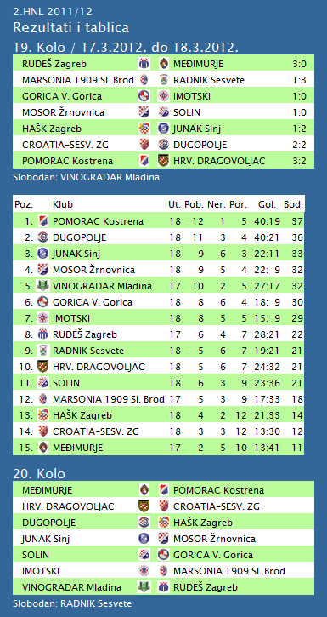

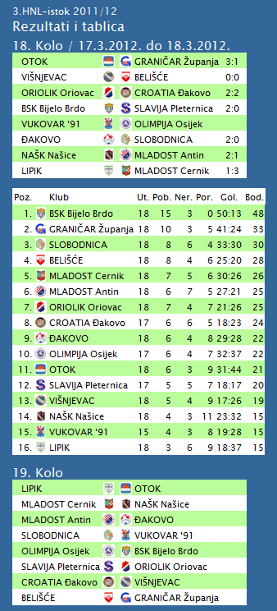

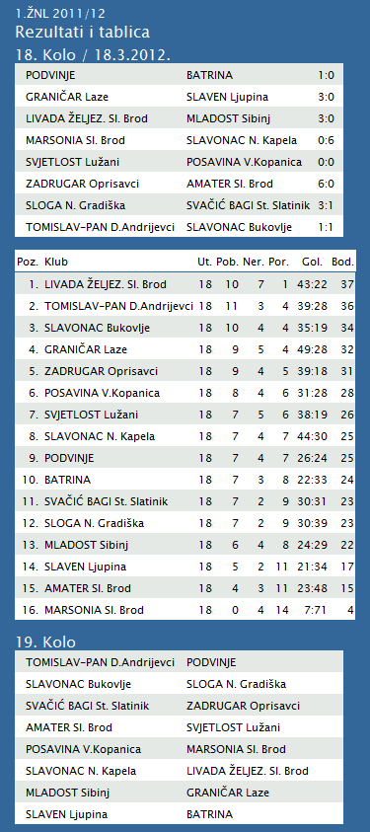

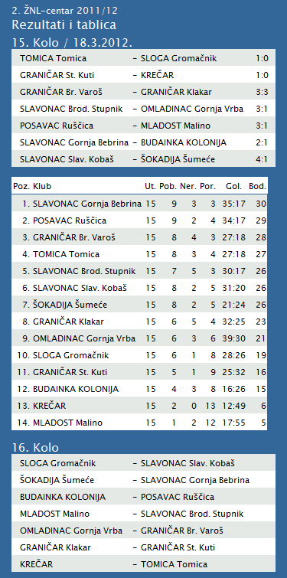

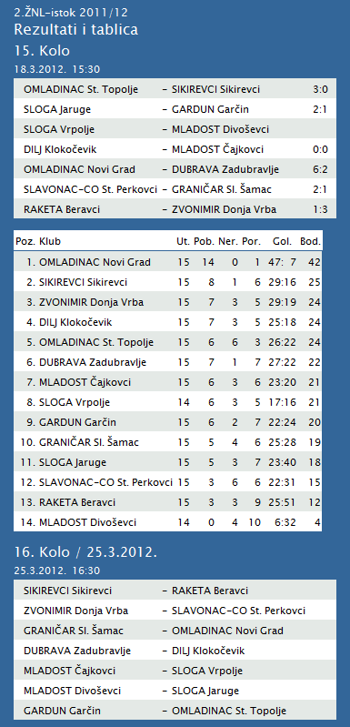

**1. HRL muški**

|  |  |  |  |  |  |  |  |
| --- | --- | --- | --- | --- | --- | --- | --- |
| **Ukupni rezultati:** | | | | | | | |
|  |  | U | P | N | P | D |  | P | +/- | B |
|  |  |  |  |  |  |  |  |  |  |  |
| 1. | VIDOVEC-BIOS | 19 | 16 | 1 | 2 | 599 | : | 469 | 130 | 33 |
|  |  |  |  |  |  |  |  |  |  |  |
| 2. | MEDVEŠČAK NFD | 19 | 15 | 2 | 2 | 598 | : | 489 | 109 | 32 |
|  |  |  |  |  |  |  |  |  |  |  |
| 3. | MOSLAVINA | 19 | 12 | 1 | 6 | 550 | : | 491 | 59 | 25 |
|  |  |  |  |  |  |  |  |  |  |  |
| 4. | DUGO SELO | 19 | 11 | 2 | 6 | 617 | : | 587 | 30 | 24 |
|  |  |  |  |  |  |  |  |  |  |  |
| 5. | OSIJEK | 19 | 10 | 1 | 8 | 570 | : | 524 | 46 | 21 |
|  |  |  |  |  |  |  |  |  |  |  |
| 6. | SENJ-WALLENBORN | 19 | 9 | 2 | 8 | 527 | : | 547 | -20 | 20 |
|  |  |  |  |  |  |  |  |  |  |  |
| 7. | UMAG | 19 | 8 | 3 | 8 | 554 | : | 538 | 16 | 19 |
|  |  |  |  |  |  |  |  |  |  |  |
| 8. | ŽUPANJA | 19 | 8 | 2 | 9 | 501 | : | 507 | -6 | 18 |
|  |  |  |  |  |  |  |  |  |  |  |
| 9. | CRIKVENICA | 19 | 8 | 1 | 10 | 480 | : | 503 | -23 | 17 |
|  |  |  |  |  |  |  |  |  |  |  |
| 10. | BIOGRAD | 19 | 8 | 1 | 10 | 539 | : | 568 | -29 | 17 |
|  |  |  |  |  |  |  |  |  |  |  |
| 11. | ĐAKOVO | 19 | 7 | 1 | 11 | 549 | : | 574 | -25 | 15 |
|  |  |  |  |  |  |  |  |  |  |  |
| 12. | MLADI RUDAR | 19 | 5 | 2 | 12 | 460 | : | 521 | -61 | 11 |
|  |  |  |  |  |  |  |  |  |  |  |
| 13. | IVANČICA IVANEC | 19 | 4 | 1 | 14 | 514 | : | 580 | -66 | 9 |
|  |  |  |  |  |  |  |  |  |  |  |
| 14. | BROD | 19 | 2 | 0 | 17 | 500 | : | 660 | -160 | 4 |
|  |  |  |  |  |  |  |  |  |  |  |

**2. HRL sjever žene**

|  |  |  |  |  |  |  |  |  |  |  |  |
| --- | --- | --- | --- | --- | --- | --- | --- | --- | --- | --- | --- |
| **Ukupni rezultati:** | | | | | | | | | | | |
|  | | |  | | U | P | N | P | D | |  | P | +/- | | B | |
|  | | |  | |  |  |  |  |  | |  |  |  | |  | |
| 1. | | | OSIJEK PSC | | 16 | 15 | 0 | 1 | 517 | | : | 327 | 190 | | 30 | |
|  | | |  | |  |  |  |  |  | |  |  |  | |  | |
| 2. | | | BJELOVAR | | 16 | 11 | 1 | 4 | 487 | | : | 460 | 27 | | 23 | |
|  | | |  | |  |  |  |  |  | |  |  |  | |  | |
| 3. | | | BROD-GYMNASIUM | | 16 | 10 | 2 | 4 | 450 | | : | 383 | 67 | | 22 | |
|  | | |  | |  |  |  |  |  | |  |  |  | |  | |
| 4. | | | PODRAVKA-LINO | | 16 | 10 | 2 | 4 | 478 | | : | 440 | 38 | | 22 | |
|  | | |  | |  |  |  |  |  | |  |  |  | |  | |
| 5. | | | ZRINSKI | | 16 | 9 | 1 | 6 | 459 | | : | 443 | 16 | | 19 | |
|  | | |  | |  |  |  |  |  | |  |  |  | |  | |
| 6. | | | PITOMAČA | | 16 | 8 | 2 | 6 | 488 | | : | 481 | 7 | | 18 | |
|  | | |  | |  |  |  |  |  | |  |  |  | |  | |
| 7. | | | PETRIJEVCI | | 16 | 8 | 1 | 7 | 528 | | : | 503 | 25 | | 17 | |
|  | | |  | |  |  |  |  |  | |  |  |  | |  | |
| 8. | | | ĐURĐEVAC | | 16 | 8 | 0 | 8 | 456 | | : | 483 | -27 | | 16 | |
|  | | |  | |  |  |  |  |  | |  |  |  | |  | |
| 9. | | | DARDA | | 16 | 6 | 0 | 10 | 465 | | : | 475 | -10 | | 12 | |
|  | | |  | |  |  |  |  |  | |  |  |  | |  | |
| 10. | | | CERNA | | 16 | 3 | 0 | 13 | 376 | | : | 464 | -88 | | 6 | |
|  | | |  | |  |  |  |  |  | |  |  |  | |  | |
| 11. | | | IVANEC | | 16 | 2 | 1 | 13 | 418 | | : | 537 | -119 | | 5 | |
|  | | |  | |  |  |  |  |  | |  |  |  | |  | |
| 12. | | | VUKOVAR | | 16 | 1 | 0 | 15 | 346 | | : | 472 | -126 | | 2 | |
|  | | |  | |  |  |  |  |  | |  |  |  | |  | |
|  | | |  | |  |  |  |  |  | |  |  |  | |  | |
| **TABLICA A1 MUŠKA LIGA ZA PRVAKA** | | | | | | | | | | | | | | | | | | | | | |
| http://stats.stilu.net/templates/images/separator.gif | | | | | | | | | | | | | | | | | | | | | |
| **#** | | | **Klub** | | | | | | **W** | | | | **L** | | **Bod** | | **Omjer** | | | **Razlika** | |
| http://stats.stilu.net/templates/images/separator.gif | | | | | | | | | | | | | | | | | | | | | |
| http://stats.stilu.net/templates/images/spacer.gif | **1** | | [**KK Zagreb**](javascript:;) | | | | | | 1 | | | | 0 | | 2 | | 112 | : | 75 | 37 | http://stats.stilu.net/templates/images/spacer.gif |
| http://stats.stilu.net/templates/images/separator.gif | | | | | | | | | | | | | | | | | | | | | |
| http://stats.stilu.net/templates/images/spacer.gif | **2** | | [**KK Zadar**](javascript:;) | | | | | | 1 | | | | 0 | | 2 | | 92 | : | 59 | 33 | http://stats.stilu.net/templates/images/spacer.gif |
| http://stats.stilu.net/templates/images/separator.gif | | | | | | | | | | | | | | | | | | | | | |
| http://stats.stilu.net/templates/images/spacer.gif | **3** | | [**KK Cedevita**](javascript:;) | | | | | | 1 | | | | 0 | | 2 | | 101 | : | 79 | 22 | http://stats.stilu.net/templates/images/spacer.gif |
| http://stats.stilu.net/templates/images/separator.gif | | | | | | | | | | | | | | | | | | | | | |
| http://stats.stilu.net/templates/images/spacer.gif | **4** | | [**KK Cibona**](javascript:;) | | | | | | 1 | | | | 0 | | 2 | | 89 | : | 69 | 20 | http://stats.stilu.net/templates/images/spacer.gif |
| http://stats.stilu.net/templates/images/separator.gif | | | | | | | | | | | | | | | | | | | | | |
| http://stats.stilu.net/templates/images/spacer.gif | **5** | | [**KK Brod Svjetlost**](javascript:;) | | | | | | 0 | | | | 1 | | 1 | | 69 | : | 89 | -20 | http://stats.stilu.net/templates/images/spacer.gif |
| http://stats.stilu.net/templates/images/separator.gif | | | | | | | | | | | | | | | | | | | | | |
| http://stats.stilu.net/templates/images/spacer.gif | **6** | | [**KK Split**](javascript:;) | | | | | | 0 | | | | 1 | | 1 | | 79 | : | 101 | -22 | http://stats.stilu.net/templates/images/spacer.gif |
| http://stats.stilu.net/templates/images/separator.gif | | | | | | | | | | | | | | | | | | | | | |
| http://stats.stilu.net/templates/images/spacer.gif | **7** | | [**KK Zabok**](javascript:;) | | | | | | 0 | | | | 1 | | 1 | | 59 | : | 92 | -33 | http://stats.stilu.net/templates/images/spacer.gif |
| http://stats.stilu.net/templates/images/separator.gif | | | | | | | | | | | | | | | | | | | | | |
| http://stats.stilu.net/templates/images/spacer.gif | **8** | | [**KK Jolly JBS**](javascript:;) | | | | | | 0 | | | | 1 | | 1 | | 75 | : | 112 | -37 |  |