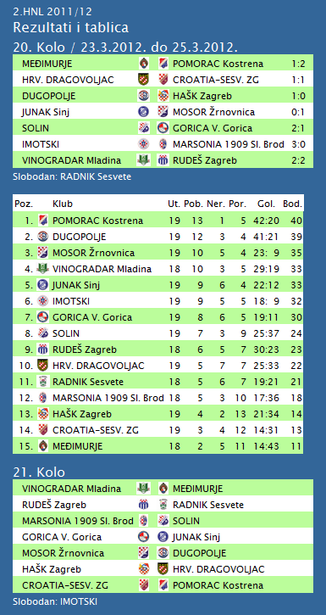

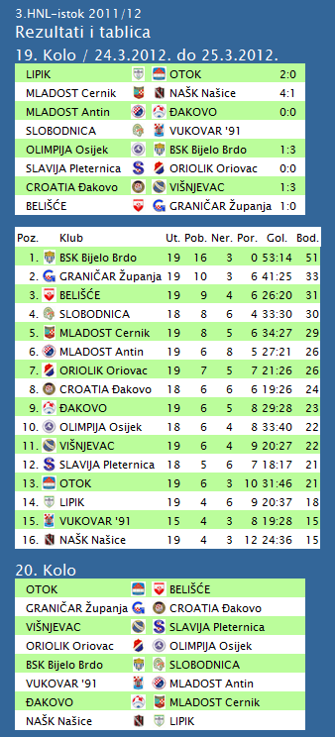

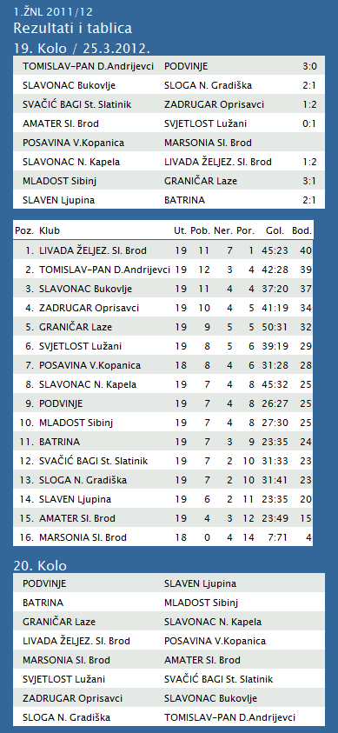

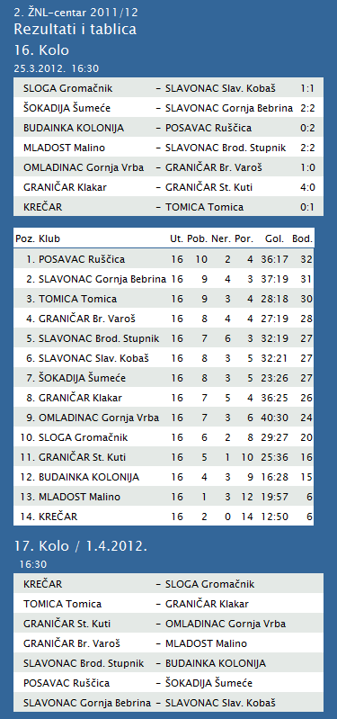

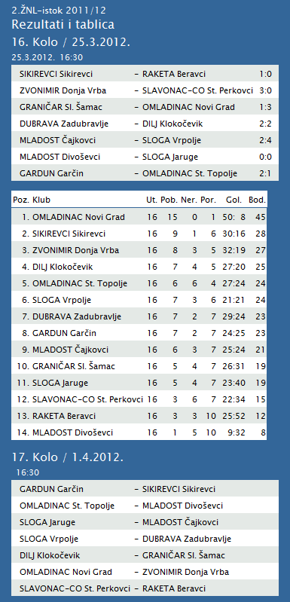

**1. HRL muški**

|  |  |  |  |  |  |  |  |
| --- | --- | --- | --- | --- | --- | --- | --- |
| **Ukupni rezultati:** | | | | | | | |
|  |  | U | P | N | P | D |  | P | +/- | B |
|  |  |  |  |  |  |  |  |  |  |  |
| 1. | VIDOVEC-BIOS | 20 | 17 | 1 | 2 | 628 | : | 486 | 142 | 35 |
|  |  |  |  |  |  |  |  |  |  |  |
| 2. | MEDVEŠČAK NFD | 20 | 16 | 2 | 2 | 634 | : | 519 | 115 | 34 |
|  |  |  |  |  |  |  |  |  |  |  |
| 3. | MOSLAVINA | 20 | 13 | 1 | 6 | 576 | : | 516 | 60 | 27 |
|  |  |  |  |  |  |  |  |  |  |  |
| 4. | DUGO SELO | 20 | 12 | 2 | 6 | 650 | : | 614 | 36 | 26 |
|  |  |  |  |  |  |  |  |  |  |  |
| 5. | OSIJEK | 20 | 11 | 1 | 8 | 613 | : | 553 | 60 | 23 |
|  |  |  |  |  |  |  |  |  |  |  |
| 6. | UMAG | 20 | 9 | 3 | 8 | 592 | : | 563 | 29 | 21 |
|  |  |  |  |  |  |  |  |  |  |  |
| 7. | SENJ-WALLENBORN | 20 | 9 | 2 | 9 | 552 | : | 573 | -21 | 20 |
|  |  |  |  |  |  |  |  |  |  |  |
| 8. | ŽUPANJA | 20 | 8 | 2 | 10 | 518 | : | 536 | -18 | 18 |
|  |  |  |  |  |  |  |  |  |  |  |
| 9. | CRIKVENICA | 20 | 8 | 1 | 11 | 507 | : | 536 | -29 | 17 |
|  |  |  |  |  |  |  |  |  |  |  |
| 10. | BIOGRAD | 20 | 8 | 1 | 11 | 568 | : | 611 | -43 | 17 |
|  |  |  |  |  |  |  |  |  |  |  |
| 11. | ĐAKOVO | 20 | 7 | 1 | 12 | 579 | : | 610 | -31 | 15 |
|  |  |  |  |  |  |  |  |  |  |  |
| 12. | MLADI RUDAR | 20 | 6 | 2 | 12 | 500 | : | 540 | -40 | 13 |
|  |  |  |  |  |  |  |  |  |  |  |
| 13. | IVANČICA IVANEC | 20 | 4 | 1 | 15 | 539 | : | 618 | -79 | 9 |
|  |  |  |  |  |  |  |  |  |  |  |
| 14. | BROD | 20 | 2 | 0 | 18 | 519 | : | 700 | -181 | 4 |
|  |  |  |  |  |  |  |  |  |  |  |

**2. HRL sjever žene**

|  |  |  |  |  |  |  |  |
| --- | --- | --- | --- | --- | --- | --- | --- |
| **Ukupni rezultati:** | | | | | | | |
|  |  | U | P | N | P | D |  | P | +/- | B |
|  |  |  |  |  |  |  |  |  |  |  |
| 1. | OSIJEK PSC | 17 | 16 | 0 | 1 | 546 | : | 347 | 199 | 32 |
|  |  |  |  |  |  |  |  |  |  |  |
| 2. | BJELOVAR | 17 | 12 | 1 | 4 | 523 | : | 485 | 38 | 25 |
|  |  |  |  |  |  |  |  |  |  |  |
| 3. | PODRAVKA-LINO | 17 | 11 | 2 | 4 | 513 | : | 472 | 41 | 24 |
|  |  |  |  |  |  |  |  |  |  |  |
| 4. | BROD-GYMNASIUM | 17 | 10 | 2 | 5 | 470 | : | 412 | 58 | 22 |
|  |  |  |  |  |  |  |  |  |  |  |
| 5. | ZRINSKI | 17 | 10 | 1 | 6 | 491 | : | 473 | 18 | 21 |
|  |  |  |  |  |  |  |  |  |  |  |
| 6. | PETRIJEVCI | 17 | 9 | 1 | 7 | 560 | : | 528 | 32 | 19 |
|  |  |  |  |  |  |  |  |  |  |  |
| 7. | PITOMAČA | 17 | 8 | 2 | 7 | 520 | : | 516 | 4 | 18 |
|  |  |  |  |  |  |  |  |  |  |  |
| 8. | ĐURĐEVAC | 17 | 8 | 0 | 9 | 486 | : | 515 | -29 | 16 |
|  |  |  |  |  |  |  |  |  |  |  |
| 9. | DARDA | 17 | 6 | 0 | 11 | 491 | : | 508 | -17 | 12 |
|  |  |  |  |  |  |  |  |  |  |  |
| 10. | IVANEC | 17 | 3 | 1 | 13 | 451 | : | 563 | -112 | 7 |
|  |  |  |  |  |  |  |  |  |  |  |
| 11. | CERNA | 17 | 3 | 0 | 14 | 401 | : | 500 | -99 | 6 |
|  |  |  |  |  |  |  |  |  |  |  |
| 12. | VUKOVAR | 17 | 1 | 0 | 16 | 371 | : | 504 | -133 | 2 |
|  |  |  |  |  |  |  |  |  |  |  |

|  |  |  |  |  |  |  |  |  |  |  |  |  |  |  |  |  |  |  |  |  |  |  |  |  |  |  |  |  |  |  |  |  |  |  |  |  |  |  |  |  |  |  |  |  |  |  |  |  |  |  |  |  |  |  |  |  |  |  |  |  |  |  |  |  |  |  |  |  |  |  |  |  |  |  |  |  |  |  |  |  |  |  |  |  |  |  |  |  |  |  |  |  |  |  |  |  |  |  |  |  |  |  |  |  |  |  |  |  |  |  |  |  |  |  |  |  |  |  |  |  |  |  |  |  |  |  |  |  |  |  |  |  |  |  |  |  |  |  |  |  |  |  |  |  |  |  |  |  |  |  |  |  |  |  |  |  |  |  |  |  |  |  |  |  |  |  |  |  |  |  |  |  |  |  |  |  |  |  |  |  |  |  |  |  |  |  |  |  |  |
| --- | --- | --- | --- | --- | --- | --- | --- | --- | --- | --- | --- | --- | --- | --- | --- | --- | --- | --- | --- | --- | --- | --- | --- | --- | --- | --- | --- | --- | --- | --- | --- | --- | --- | --- | --- | --- | --- | --- | --- | --- | --- | --- | --- | --- | --- | --- | --- | --- | --- | --- | --- | --- | --- | --- | --- | --- | --- | --- | --- | --- | --- | --- | --- | --- | --- | --- | --- | --- | --- | --- | --- | --- | --- | --- | --- | --- | --- | --- | --- | --- | --- | --- | --- | --- | --- | --- | --- | --- | --- | --- | --- | --- | --- | --- | --- | --- | --- | --- | --- | --- | --- | --- | --- | --- | --- | --- | --- | --- | --- | --- | --- | --- | --- | --- | --- | --- | --- | --- | --- | --- | --- | --- | --- | --- | --- | --- | --- | --- | --- | --- | --- | --- | --- | --- | --- | --- | --- | --- | --- | --- | --- | --- | --- | --- | --- | --- | --- | --- | --- | --- | --- | --- | --- | --- | --- | --- | --- | --- | --- | --- | --- | --- | --- | --- | --- | --- | --- | --- | --- | --- | --- | --- | --- | --- | --- | --- | --- | --- | --- | --- | --- | --- | --- | --- | --- | --- | --- | --- | --- |
| |  | | --- | |  | | |  |  |  |  |  | | --- | --- | --- | --- | --- | | |  |  |  |  | | --- | --- | --- | --- | | **NATJECANJA** |  | |  | | --- | |  | | | | |  |  |  |  |  |  |  |  |  |  |  |  |  |  |  |  |  |  |  |  |  |  |  |  |  |  |  |  |  |  |  |  |  |  |  |  |  |  |  |  |  |  |  |  |  |  |  |  |  |  |  |  |  |  |  |  |  |  |  |  |  |  |  |  |  |  |  |  |  |  |  |  |  |  |  |  |  |  |  |  |  |  |  |  |  |  |  |  |  |  |  |  |  |  |  |  |  |  |  |  |  |  |  |  |  |  |  |  |  |  |  |  |  |  |  |  |  |  |  |  |  |  |  |  |  |  |  |  |  |  |  |  |  |  |  |  |  |  |  |  |  |  |  |  |  |  |  |  |  |  |  |  |  |  |  |  |  |  |  |  |  |  |  |  |  |  |  |  |  |  |  |  |  |  |  |  |  |  |  |  |  | | --- | --- | --- | --- | --- | --- | --- | --- | --- | --- | --- | --- | --- | --- | --- | --- | --- | --- | --- | --- | --- | --- | --- | --- | --- | --- | --- | --- | --- | --- | --- | --- | --- | --- | --- | --- | --- | --- | --- | --- | --- | --- | --- | --- | --- | --- | --- | --- | --- | --- | --- | --- | --- | --- | --- | --- | --- | --- | --- | --- | --- | --- | --- | --- | --- | --- | --- | --- | --- | --- | --- | --- | --- | --- | --- | --- | --- | --- | --- | --- | --- | --- | --- | --- | --- | --- | --- | --- | --- | --- | --- | --- | --- | --- | --- | --- | --- | --- | --- | --- | --- | --- | --- | --- | --- | --- | --- | --- | --- | --- | --- | --- | --- | --- | --- | --- | --- | --- | --- | --- | --- | --- | --- | --- | --- | --- | --- | --- | --- | --- | --- | --- | --- | --- | --- | --- | --- | --- | --- | --- | --- | --- | --- | --- | --- | --- | --- | --- | --- | --- | --- | --- | --- | --- | --- | --- | --- | --- | --- | --- | --- | --- | --- | --- | --- | --- | --- | --- | --- | --- | --- | --- | --- | --- | --- | --- | --- | --- | --- | --- | --- | | Vrh obrasca   |  | | --- | | [1. A liga - seniorke](http://hou.hr/index.php?rubrika=utakmica&natjecanje=307) | | |  |  |  |  |  |  |  |  |  |  |  |  | | --- | --- | --- | --- | --- | --- | --- | --- | --- | --- | --- | --- | |  | **EKIPA** | **UTAKMICE** | | | **SETOVI** | | | **POENI** | | | **BODOVI** | |  | uk. | dob. | izg. | dob. | izg. | kol. | dob. | izg. | kol. | | **1.** | [ŽOK SPLIT 1700](http://hou.hr/index.php?rubrika=ekipa&obrazac=1&id=38) | 24 | 22 | 2 | 70 | 8 | 8.7500 | 1890 | 1296 | 1.4583 | **67** | | **2.** | [HAOK MLADOST](http://hou.hr/index.php?rubrika=ekipa&obrazac=1&id=39) | 24 | 19 | 5 | 63 | 25 | 2.5200 | 2051 | 1718 | 1.1938 | **56** | | **3.** | [OK OTP BANKA PULA](http://hou.hr/index.php?rubrika=ekipa&obrazac=1&id=31) | 24 | 19 | 5 | 59 | 30 | 1.9667 | 1998 | 1702 | 1.1739 | **54** | | **4.** | [OK MARINA KAŠTELA](http://hou.hr/index.php?rubrika=ekipa&obrazac=1&id=54) | 24 | 18 | 6 | 60 | 32 | 1.8750 | 2102 | 1915 | 1.0977 | **52** | | **5.** | [ŽOK AZENA VELIKA GORICA](http://hou.hr/index.php?rubrika=ekipa&obrazac=1&id=34) | 24 | 15 | 9 | 55 | 34 | 1.6176 | 2026 | 1736 | 1.1671 | **46** | | **6.** | [OK POREČ](http://hou.hr/index.php?rubrika=ekipa&obrazac=1&id=332) | 24 | 14 | 10 | 50 | 43 | 1.1628 | 2093 | 1985 | 1.0544 | **39** | | **7.** | [OK KAŠTELA DC](http://hou.hr/index.php?rubrika=ekipa&obrazac=1&id=32) | 24 | 12 | 12 | 51 | 47 | 1.0851 | 2066 | 2012 | 1.0268 | **39** | | **8.** | [ŽOK CESTORAD](http://hou.hr/index.php?rubrika=ekipa&obrazac=1&id=29) | 24 | 11 | 13 | 43 | 46 | 0.9348 | 1870 | 1905 | 0.9816 | **35** | | **9.** | [OK KOSTRENA](http://hou.hr/index.php?rubrika=ekipa&obrazac=1&id=58) | 24 | 10 | 14 | 37 | 53 | 0.6981 | 1868 | 2005 | 0.9317 | **26** | | **10.** | [OK ZAGREB](http://hou.hr/index.php?rubrika=ekipa&obrazac=1&id=36) | 24 | 7 | 17 | 33 | 57 | 0.5789 | 1838 | 2046 | 0.8983 | **23** | | **11.** | [OK GROBNIČAN](http://hou.hr/index.php?rubrika=ekipa&obrazac=1&id=35) | 24 | 5 | 19 | 25 | 62 | 0.4032 | 1720 | 2006 | 0.8574 | **16** | | **12.** | [ŽOK OSIJEK](http://hou.hr/index.php?rubrika=ekipa&obrazac=1&id=81) | 24 | 4 | 20 | 25 | 62 | 0.4032 | 1731 | 2002 | 0.8646 | **15** | | **13.** | [ŽOK MARSONIA](http://hou.hr/index.php?rubrika=ekipa&obrazac=1&id=37) | 24 | 0 | 24 | 0 | 72 | 0.0000 | 875 | 1800 | 0.4861 | **-1** | |   Dno obrasca | | |

|  |  |  |  |  |  |  |  |  |  |  |
| --- | --- | --- | --- | --- | --- | --- | --- | --- | --- | --- |
| **TABLICA A1 MUŠKA LIGA ZA PRVAKA** | | | | | | | | | | |
| http://stats.stilu.net/templates/images/separator.gif | | | | | | | | | | |
| **#** | | **Klub** | **W** | **L** | **Bod** | **Omjer** | | | **Razlika** | |
| http://stats.stilu.net/templates/images/separator.gif | | | | | | | | | | |
| http://stats.stilu.net/templates/images/spacer.gif | **1** | [**KK Zadar**](javascript:;) | 2 | 1 | 5 | 236 | : | 188 | 48 | http://stats.stilu.net/templates/images/spacer.gif |
| http://stats.stilu.net/templates/images/separator.gif | | | | | | | | | | |
| http://stats.stilu.net/templates/images/spacer.gif | **2** | [**KK Split**](javascript:;) | 2 | 1 | 5 | 264 | : | 252 | 12 | http://stats.stilu.net/templates/images/spacer.gif |
| http://stats.stilu.net/templates/images/separator.gif | | | | | | | | | | |
| http://stats.stilu.net/templates/images/spacer.gif | **3** | [**KK Zagreb**](javascript:;) | 2 | 1 | 5 | 290 | : | 280 | 10 | http://stats.stilu.net/templates/images/spacer.gif |
| http://stats.stilu.net/templates/images/separator.gif | | | | | | | | | | |
| http://stats.stilu.net/templates/images/spacer.gif | **4** | [**KK Cedevita** *(-1)*](javascript:;) | 2 | 0 | 4 | 196 | : | 149 | 47 | http://stats.stilu.net/templates/images/spacer.gif |
| http://stats.stilu.net/templates/images/separator.gif | | | | | | | | | | |
| http://stats.stilu.net/templates/images/spacer.gif | **5** | [**KK Cibona** *(-1)*](javascript:;) | 2 | 0 | 4 | 184 | : | 144 | 40 | http://stats.stilu.net/templates/images/spacer.gif |
| http://stats.stilu.net/templates/images/separator.gif | | | | | | | | | | |
| http://stats.stilu.net/templates/images/spacer.gif | **6** | [**KK Brod Svjetlost**](javascript:;) | 0 | 3 | 3 | 189 | : | 255 | -66 | http://stats.stilu.net/templates/images/spacer.gif |
| http://stats.stilu.net/templates/images/separator.gif | | | | | | | | | | |
| http://stats.stilu.net/templates/images/spacer.gif | **7** | [**KK Zabok** *(-1)*](javascript:;) | 0 | 2 | 2 | 158 | : | 192 | -34 | http://stats.stilu.net/templates/images/spacer.gif |
| http://stats.stilu.net/templates/images/separator.gif | | | | | | | | | | |
| http://stats.stilu.net/templates/images/spacer.gif | **8** | [**KK Jolly JBS** *(-1)*](javascript:;) | 0 | 2 | 2 | 150 | : | 207 | -57 | http://stats.stilu.net/templates/images/spacer.gif |
| http://stats.stilu.net/templates/images/separator.gif | | | | | | | | | | |