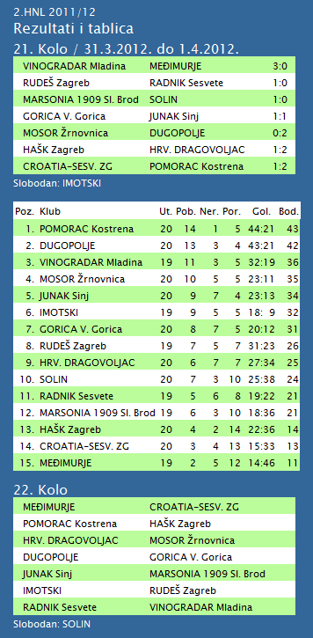

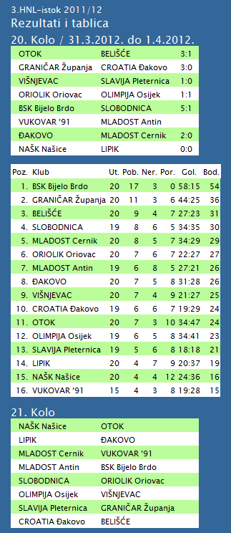

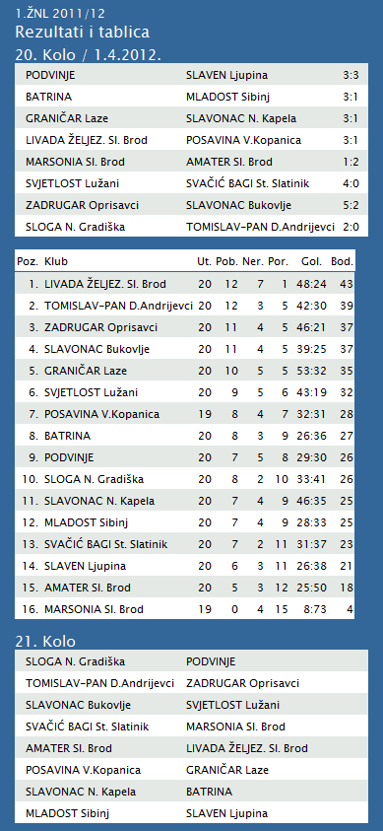

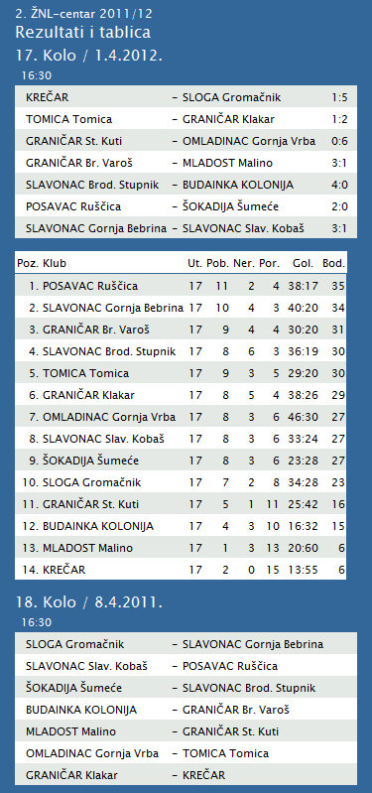

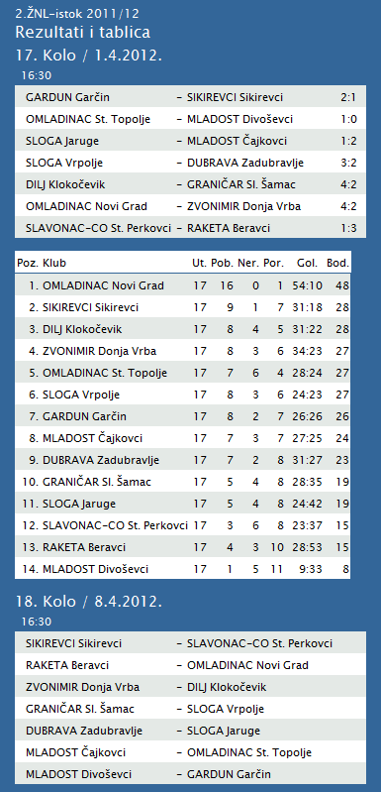

**1. HRL muški**

|  |  |  |  |  |  |  |  |
| --- | --- | --- | --- | --- | --- | --- | --- |
| **Ukupni rezultati:** | | | | | | | |
|  |  | U | P | N | P | D |  | P | +/- | B |
|  |  |  |  |  |  |  |  |  |  |  |
| 1. | MEDVEŠČAK NFD | 21 | 17 | 2 | 2 | 667 | : | 547 | 120 | 36 |
|  |  |  |  |  |  |  |  |  |  |  |
| 2. | VIDOVEC-BIOS | 21 | 17 | 1 | 3 | 661 | : | 522 | 139 | 35 |
|  |  |  |  |  |  |  |  |  |  |  |
| 3. | MOSLAVINA | 20 | 13 | 1 | 6 | 576 | : | 516 | 60 | 27 |
|  |  |  |  |  |  |  |  |  |  |  |
| 4. | DUGO SELO | 21 | 12 | 2 | 7 | 675 | : | 647 | 28 | 26 |
|  |  |  |  |  |  |  |  |  |  |  |
| 5. | OSIJEK | 21 | 11 | 1 | 9 | 641 | : | 586 | 55 | 23 |
|  |  |  |  |  |  |  |  |  |  |  |
| 6. | SENJ-WALLENBORN | 21 | 10 | 2 | 9 | 583 | : | 603 | -20 | 22 |
|  |  |  |  |  |  |  |  |  |  |  |
| 7. | UMAG | 21 | 9 | 3 | 9 | 622 | : | 594 | 28 | 21 |
|  |  |  |  |  |  |  |  |  |  |  |
| 8. | ŽUPANJA | 21 | 9 | 2 | 10 | 551 | : | 561 | -10 | 20 |
|  |  |  |  |  |  |  |  |  |  |  |
| 9. | BIOGRAD | 21 | 9 | 1 | 11 | 604 | : | 644 | -40 | 19 |
|  |  |  |  |  |  |  |  |  |  |  |
| 10. | ĐAKOVO | 21 | 8 | 1 | 12 | 610 | : | 636 | -26 | 17 |
|  |  |  |  |  |  |  |  |  |  |  |
| 11. | CRIKVENICA | 20 | 8 | 1 | 11 | 507 | : | 536 | -29 | 17 |
|  |  |  |  |  |  |  |  |  |  |  |
| 12. | MLADI RUDAR | 21 | 6 | 2 | 13 | 526 | : | 571 | -45 | 13 |
|  |  |  |  |  |  |  |  |  |  |  |
| 13. | IVANČICA IVANEC | 21 | 5 | 1 | 15 | 574 | : | 640 | -66 | 11 |
|  |  |  |  |  |  |  |  |  |  |  |
| 14. | BROD | 21 | 2 | 0 | 19 | 541 | : | 735 | -194 | 4 |
|  |  |  |  |  |  |  |  |  |  |  |

**2. HRL sjever žene**

|  |  |  |  |  |  |  |  |
| --- | --- | --- | --- | --- | --- | --- | --- |
| **Ukupni rezultati:** | | | | | | | |
|  |  | U | P | N | P | D |  | P | +/- | B |
|  |  |  |  |  |  |  |  |  |  |  |
| 1. | OSIJEK PSC | 18 | 17 | 0 | 1 | 574 | : | 364 | 210 | 34 |
|  |  |  |  |  |  |  |  |  |  |  |
| 2. | BJELOVAR | 18 | 13 | 1 | 4 | 566 | : | 514 | 52 | 27 |
|  |  |  |  |  |  |  |  |  |  |  |
| 3. | PODRAVKA-LINO | 17 | 11 | 2 | 4 | 513 | : | 472 | 41 | 24 |
|  |  |  |  |  |  |  |  |  |  |  |
| 4. | BROD-GYMNASIUM | 17 | 10 | 2 | 5 | 470 | : | 412 | 58 | 22 |
|  |  |  |  |  |  |  |  |  |  |  |
| 5. | ZRINSKI | 17 | 10 | 1 | 6 | 491 | : | 473 | 18 | 21 |
|  |  |  |  |  |  |  |  |  |  |  |
| 6. | PITOMAČA | 18 | 9 | 2 | 7 | 564 | : | 538 | 26 | 20 |
|  |  |  |  |  |  |  |  |  |  |  |
| 7. | PETRIJEVCI | 18 | 9 | 1 | 8 | 589 | : | 571 | 18 | 19 |
|  |  |  |  |  |  |  |  |  |  |  |
| 8. | ĐURĐEVAC | 18 | 9 | 0 | 9 | 521 | : | 546 | -25 | 18 |
|  |  |  |  |  |  |  |  |  |  |  |
| 9. | DARDA | 17 | 6 | 0 | 11 | 491 | : | 508 | -17 | 12 |
|  |  |  |  |  |  |  |  |  |  |  |
| 10. | IVANEC | 18 | 3 | 1 | 14 | 473 | : | 607 | -134 | 7 |
|  |  |  |  |  |  |  |  |  |  |  |
| 11. | CERNA | 18 | 3 | 0 | 15 | 418 | : | 528 | -110 | 6 |
|  |  |  |  |  |  |  |  |  |  |  |
| 12. | VUKOVAR | 18 | 1 | 0 | 17 | 402 | : | 539 | -137 | 2 |

|  |  |  |  |  |  |  |  |  |  |  |
| --- | --- | --- | --- | --- | --- | --- | --- | --- | --- | --- |
| **TABLICA A1 MUŠKA LIGA ZA PRVAKA** | | | | | | | | | | |
| http://stats.stilu.net/templates/images/separator.gif | | | | | | | | | | |
| **#** | | **Klub** | **W** | **L** | **Bod** | **Omjer** | | | **Razlika** | |
| http://stats.stilu.net/templates/images/separator.gif | | | | | | | | | | |
| http://stats.stilu.net/templates/images/spacer.gif | **1** | [**KK Cibona**](javascript:;) | 4 | 0 | 8 | 348 | : | 275 | 73 | http://stats.stilu.net/templates/images/spacer.gif |
| http://stats.stilu.net/templates/images/separator.gif | | | | | | | | | | |
| http://stats.stilu.net/templates/images/spacer.gif | **2** | [**KK Cedevita**](javascript:;) | 3 | 1 | 7 | 348 | : | 281 | 67 | http://stats.stilu.net/templates/images/spacer.gif |
| http://stats.stilu.net/templates/images/separator.gif | | | | | | | | | | |
| http://stats.stilu.net/templates/images/spacer.gif | **3** | [**KK Zagreb**](javascript:;) | 3 | 1 | 7 | 403 | : | 342 | 61 | http://stats.stilu.net/templates/images/spacer.gif |
| http://stats.stilu.net/templates/images/separator.gif | | | | | | | | | | |
| http://stats.stilu.net/templates/images/spacer.gif | **4** | [**KK Split**](javascript:;) | 3 | 1 | 7 | 350 | : | 329 | 21 | http://stats.stilu.net/templates/images/spacer.gif |
| http://stats.stilu.net/templates/images/separator.gif | | | | | | | | | | |
| http://stats.stilu.net/templates/images/spacer.gif | **5** | [**KK Zadar**](javascript:;) | 2 | 2 | 6 | 292 | : | 271 | 21 | http://stats.stilu.net/templates/images/spacer.gif |
| http://stats.stilu.net/templates/images/separator.gif | | | | | | | | | | |
| http://stats.stilu.net/templates/images/spacer.gif | **6** | [**KK Zabok**](javascript:;) | 1 | 3 | 5 | 303 | : | 361 | -58 | http://stats.stilu.net/templates/images/spacer.gif |
| http://stats.stilu.net/templates/images/separator.gif | | | | | | | | | | |
| http://stats.stilu.net/templates/images/spacer.gif | **7** | [**KK Jolly JBS**](javascript:;) | 0 | 4 | 4 | 308 | : | 376 | -68 | http://stats.stilu.net/templates/images/spacer.gif |
| http://stats.stilu.net/templates/images/separator.gif | | | | | | | | | | |
| http://stats.stilu.net/templates/images/spacer.gif | **8** | [**KK Brod Svjetlost**](javascript:;) | 0 | 4 | 4 | 251 | : | 368 | -117 | http://stats.stilu.net/templates/images/spacer.gif |
| http://stats.stilu.net/templates/images/separator.gif | | | | | | | | | | |