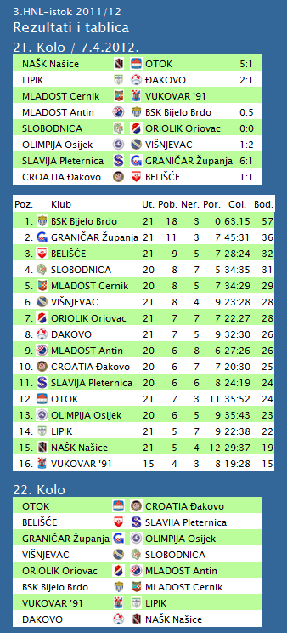

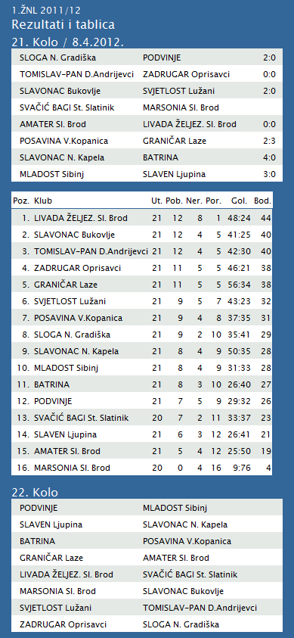

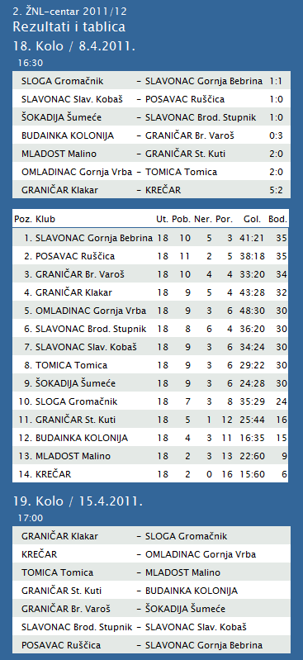

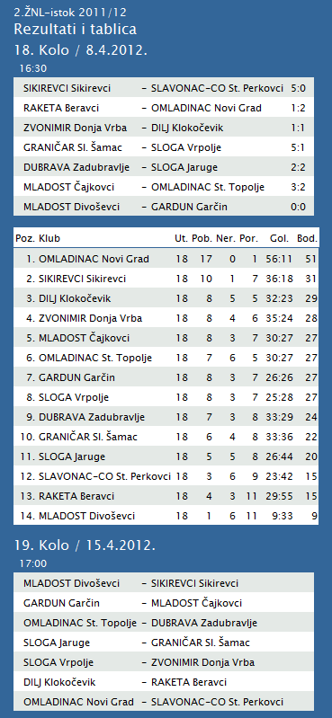

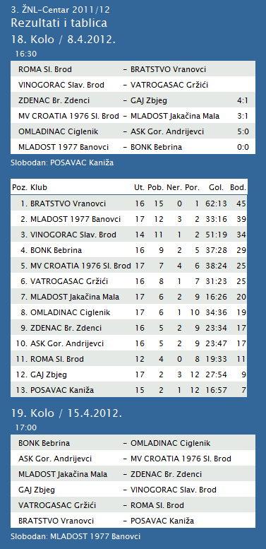

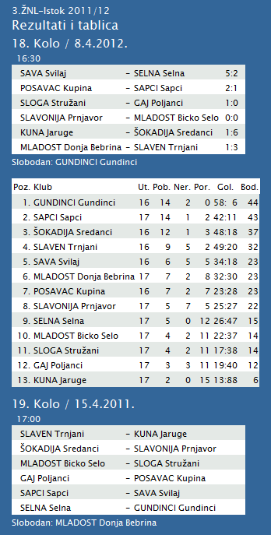

|  |  |  |  |  |  |  |  |  |  |  |
| --- | --- | --- | --- | --- | --- | --- | --- | --- | --- | --- |
| **TABLICA A1 MUŠKA LIGA ZA PRVAKA** | | | | | | | | | | |
| http://stats.stilu.net/templates/images/separator.gif | | | | | | | | | | |
| **#** | | **Klub** | **W** | **L** | **Bod** | **Omjer** | | | **Razlika** | |
| http://stats.stilu.net/templates/images/separator.gif | | | | | | | | | | |
| http://stats.stilu.net/templates/images/spacer.gif | **1** | [**KK Cibona**](javascript:;) | 7 | 0 | 14 | 609 | : | 495 | 114 | http://stats.stilu.net/templates/images/spacer.gif |
| http://stats.stilu.net/templates/images/separator.gif | | | | | | | | | | |
| http://stats.stilu.net/templates/images/spacer.gif | **2** | [**KK Cedevita**](javascript:;) | 6 | 1 | 13 | 635 | : | 527 | 108 | http://stats.stilu.net/templates/images/spacer.gif |
| http://stats.stilu.net/templates/images/separator.gif | | | | | | | | | | |
| http://stats.stilu.net/templates/images/spacer.gif | **3** | [**KK Zagreb**](javascript:;) | 3 | 4 | 10 | 623 | : | 591 | 32 | http://stats.stilu.net/templates/images/spacer.gif |
| http://stats.stilu.net/templates/images/separator.gif | | | | | | | | | | |
| http://stats.stilu.net/templates/images/spacer.gif | **4** | [**KK Split** *(-1)*](javascript:;) | 4 | 2 | 10 | 526 | : | 512 | 14 | http://stats.stilu.net/templates/images/spacer.gif |
| http://stats.stilu.net/templates/images/separator.gif | | | | | | | | | | |
| http://stats.stilu.net/templates/images/spacer.gif | **5** | [**KK Zadar** *(-1)*](javascript:;) | 3 | 3 | 9 | 435 | : | 417 | 18 | http://stats.stilu.net/templates/images/spacer.gif |
| http://stats.stilu.net/templates/images/separator.gif | | | | | | | | | | |
| http://stats.stilu.net/templates/images/spacer.gif | **6** | [**KK Zabok**](javascript:;) | 1 | 6 | 8 | 558 | : | 639 | -81 | http://stats.stilu.net/templates/images/spacer.gif |
| http://stats.stilu.net/templates/images/separator.gif | | | | | | | | | | |
| http://stats.stilu.net/templates/images/spacer.gif | **7** | [**KK Jolly JBS** *(-1)*](javascript:;) | 1 | 5 | 7 | 446 | : | 525 | -79 | http://stats.stilu.net/templates/images/spacer.gif |
| http://stats.stilu.net/templates/images/separator.gif | | | | | | | | | | |
| http://stats.stilu.net/templates/images/spacer.gif | **8** | [**KK Brod Svjetlost** *(-1)*](javascript:;) | 1 | 5 | 7 | 385 | : | 511 | -126 | http://stats.stilu.net/templates/images/spacer.gif |
| http://stats.stilu.net/templates/images/separator.gif | | | | | | | | | | |

**2. HRL sjever žene**

|  |  |  |  |  |  |  |  |
| --- | --- | --- | --- | --- | --- | --- | --- |
| **Ukupni rezultati:** | | | | | | | |
|  |  | U | P | N | P | D |  | P | +/- | B |
|  |  |  |  |  |  |  |  |  |  |  |
| 1. | OSIJEK PSC | 18 | 17 | 0 | 1 | 574 | : | 364 | 210 | 34 |
|  |  |  |  |  |  |  |  |  |  |  |
| 2. | BJELOVAR | 18 | 13 | 1 | 4 | 566 | : | 514 | 52 | 27 |
|  |  |  |  |  |  |  |  |  |  |  |
| 3. | BROD-GYMNASIUM | 18 | 11 | 2 | 5 | 503 | : | 435 | 68 | 24 |
|  |  |  |  |  |  |  |  |  |  |  |
| 4. | PODRAVKA-LINO | 18 | 11 | 2 | 5 | 536 | : | 505 | 31 | 24 |
|  |  |  |  |  |  |  |  |  |  |  |
| 5. | ZRINSKI | 18 | 10 | 1 | 7 | 509 | : | 495 | 14 | 21 |
|  |  |  |  |  |  |  |  |  |  |  |
| 6. | PITOMAČA | 18 | 9 | 2 | 7 | 564 | : | 538 | 26 | 20 |
|  |  |  |  |  |  |  |  |  |  |  |
| 7. | PETRIJEVCI | 18 | 9 | 1 | 8 | 589 | : | 571 | 18 | 19 |
|  |  |  |  |  |  |  |  |  |  |  |
| 8. | ĐURĐEVAC | 18 | 9 | 0 | 9 | 521 | : | 546 | -25 | 18 |
|  |  |  |  |  |  |  |  |  |  |  |
| 9. | DARDA | 18 | 7 | 0 | 11 | 513 | : | 526 | -13 | 14 |
|  |  |  |  |  |  |  |  |  |  |  |
| 10. | IVANEC | 18 | 3 | 1 | 14 | 473 | : | 607 | -134 | 7 |
|  |  |  |  |  |  |  |  |  |  |  |
| 11. | CERNA | 18 | 3 | 0 | 15 | 418 | : | 528 | -110 | 6 |
|  |  |  |  |  |  |  |  |  |  |  |
| 12. | VUKOVAR | 18 | 1 | 0 | 17 | 402 | : | 539 | -137 | 2 |
|  |  |  |  |  |  |  |  |  |  |  |