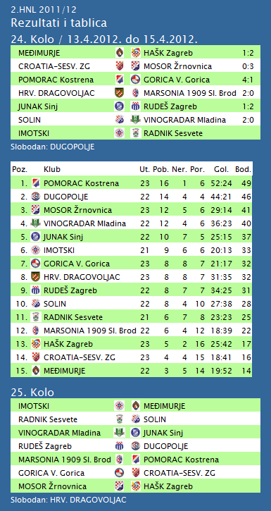

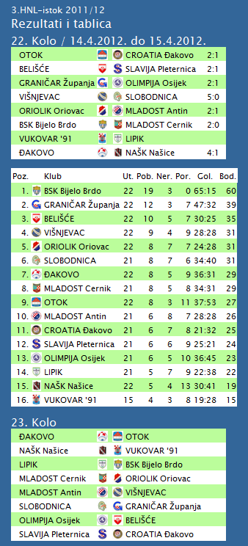

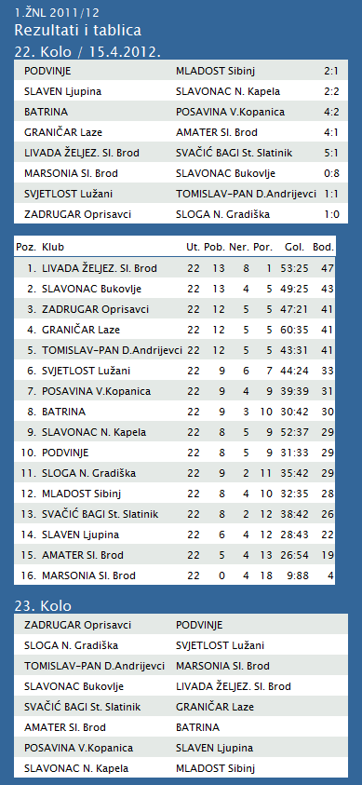

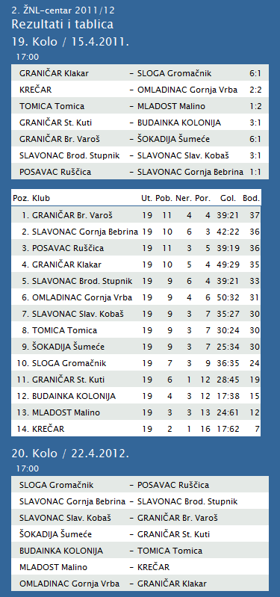

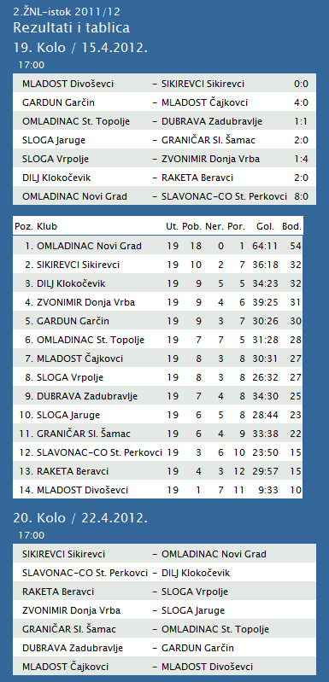

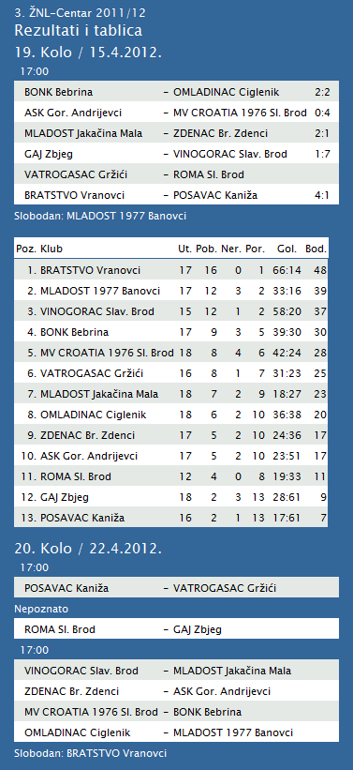

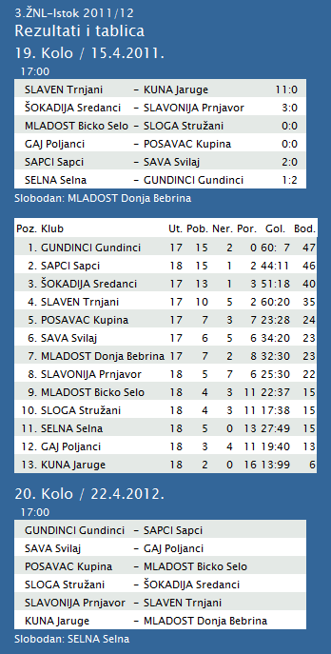

|  |  |  |  |  |  |  |  |  |  |  |
| --- | --- | --- | --- | --- | --- | --- | --- | --- | --- | --- |
| **TABLICA A1 MUŠKA LIGA ZA PRVAKA** | | | | | | | | | | |
| http://stats.stilu.net/templates/images/separator.gif | | | | | | | | | | |
| **#** | | **Klub** | **W** | **L** | **Bod** | **Omjer** | | | **Razlika** | |
| http://stats.stilu.net/templates/images/separator.gif | | | | | | | | | | |
| http://stats.stilu.net/templates/images/spacer.gif | **1** | [**KK Cibona**](javascript:;) | 9 | 0 | 18 | 799 | : | 633 | 166 | http://stats.stilu.net/templates/images/spacer.gif |
| http://stats.stilu.net/templates/images/separator.gif | | | | | | | | | | |
| http://stats.stilu.net/templates/images/spacer.gif | **2** | [**KK Cedevita**](javascript:;) | 7 | 2 | 16 | 803 | : | 670 | 133 | http://stats.stilu.net/templates/images/spacer.gif |
| http://stats.stilu.net/templates/images/separator.gif | | | | | | | | | | |
| http://stats.stilu.net/templates/images/spacer.gif | **3** | [**KK Zadar**](javascript:;) | 6 | 3 | 15 | 662 | : | 613 | 49 | http://stats.stilu.net/templates/images/spacer.gif |
| http://stats.stilu.net/templates/images/separator.gif | | | | | | | | | | |
| http://stats.stilu.net/templates/images/spacer.gif | **4** | [**KK Split**](javascript:;) | 6 | 3 | 15 | 747 | : | 735 | 12 | http://stats.stilu.net/templates/images/spacer.gif |
| http://stats.stilu.net/templates/images/separator.gif | | | | | | | | | | |
| http://stats.stilu.net/templates/images/spacer.gif | **5** | [**KK Zagreb**](javascript:;) | 5 | 4 | 14 | 814 | : | 736 | 78 | http://stats.stilu.net/templates/images/spacer.gif |
| http://stats.stilu.net/templates/images/separator.gif | | | | | | | | | | |
| http://stats.stilu.net/templates/images/spacer.gif | **6** | [**KK Zabok**](javascript:;) | 1 | 8 | 10 | 689 | : | 817 | -128 | http://stats.stilu.net/templates/images/spacer.gif |
| http://stats.stilu.net/templates/images/separator.gif | | | | | | | | | | |
| http://stats.stilu.net/templates/images/spacer.gif | **7** | [**KK Jolly JBS**](javascript:;) | 1 | 8 | 10 | 661 | : | 798 | -137 | http://stats.stilu.net/templates/images/spacer.gif |
| http://stats.stilu.net/templates/images/separator.gif | | | | | | | | | | |
| http://stats.stilu.net/templates/images/spacer.gif | **8** | [**KK Brod Svjetlost**](javascript:;) | 1 | 8 | 10 | 579 | : | 752 | -173 |  |

**1. HRL muški**

|  |  |  |  |  |  |  |  |
| --- | --- | --- | --- | --- | --- | --- | --- |
| **Ukupni rezultati:** | | | | | | | |
|  |  | U | P | N | P | D |  | P | +/- | B |
|  |  |  |  |  |  |  |  |  |  |  |
| 1. | VIDOVEC-BIOS | 22 | 18 | 1 | 3 | 689 | : | 542 | 147 | 37 |
|  |  |  |  |  |  |  |  |  |  |  |
| 2. | MEDVEŠČAK NFD | 22 | 17 | 2 | 3 | 687 | : | 575 | 112 | 36 |
|  |  |  |  |  |  |  |  |  |  |  |
| 3. | MOSLAVINA | 22 | 15 | 1 | 6 | 640 | : | 566 | 74 | 31 |
|  |  |  |  |  |  |  |  |  |  |  |
| 4. | DUGO SELO | 22 | 13 | 2 | 7 | 708 | : | 678 | 30 | 28 |
|  |  |  |  |  |  |  |  |  |  |  |
| 5. | OSIJEK | 22 | 12 | 1 | 9 | 675 | : | 610 | 65 | 25 |
|  |  |  |  |  |  |  |  |  |  |  |
| 6. | SENJ-WALLENBORN | 22 | 11 | 2 | 9 | 617 | : | 631 | -14 | 24 |
|  |  |  |  |  |  |  |  |  |  |  |
| 7. | UMAG | 22 | 10 | 3 | 9 | 654 | : | 623 | 31 | 23 |
|  |  |  |  |  |  |  |  |  |  |  |
| 8. | ŽUPANJA | 22 | 9 | 2 | 11 | 577 | : | 594 | -17 | 20 |
|  |  |  |  |  |  |  |  |  |  |  |
| 9. | BIOGRAD | 22 | 9 | 1 | 12 | 635 | : | 677 | -42 | 19 |
|  |  |  |  |  |  |  |  |  |  |  |
| 10. | ĐAKOVO | 22 | 8 | 1 | 13 | 634 | : | 670 | -36 | 17 |
|  |  |  |  |  |  |  |  |  |  |  |
| 11. | CRIKVENICA | 22 | 8 | 1 | 13 | 560 | : | 599 | -39 | 17 |
|  |  |  |  |  |  |  |  |  |  |  |
| 12. | MLADI RUDAR | 21 | 6 | 2 | 13 | 526 | : | 571 | -45 | 13 |
|  |  |  |  |  |  |  |  |  |  |  |
| 13. | IVANČICA IVANEC | 21 | 5 | 1 | 15 | 574 | : | 640 | -66 | 11 |
|  |  |  |  |  |  |  |  |  |  |  |
| 14. | BROD | 22 | 2 | 0 | 20 | 569 | : | 769 | -200 | 4 |

**2. HRL sjever žene**

|  |  |  |  |  |  |  |  |
| --- | --- | --- | --- | --- | --- | --- | --- |
| **Ukupni rezultati:** | | | | | | | |
|  |  | U | P | N | P | D |  | P | +/- | B |
|  |  |  |  |  |  |  |  |  |  |  |
| 1. | OSIJEK PSC | 19 | 18 | 0 | 1 | 612 | : | 383 | 229 | 36 |
|  |  |  |  |  |  |  |  |  |  |  |
| 2. | BJELOVAR | 19 | 14 | 1 | 4 | 602 | : | 534 | 68 | 29 |
|  |  |  |  |  |  |  |  |  |  |  |
| 3. | BROD-GYMNASIUM | 19 | 12 | 2 | 5 | 534 | : | 458 | 76 | 26 |
|  |  |  |  |  |  |  |  |  |  |  |
| 4. | PODRAVKA-LINO | 19 | 12 | 2 | 5 | 575 | : | 531 | 44 | 26 |
|  |  |  |  |  |  |  |  |  |  |  |
| 5. | PITOMAČA | 19 | 10 | 2 | 7 | 597 | : | 561 | 36 | 22 |
|  |  |  |  |  |  |  |  |  |  |  |
| 6. | ZRINSKI | 19 | 10 | 1 | 8 | 532 | : | 528 | 4 | 21 |
|  |  |  |  |  |  |  |  |  |  |  |
| 7. | PETRIJEVCI | 19 | 9 | 1 | 9 | 608 | : | 609 | -1 | 19 |
|  |  |  |  |  |  |  |  |  |  |  |
| 8. | ĐURĐEVAC | 19 | 9 | 0 | 10 | 546 | : | 578 | -32 | 18 |
|  |  |  |  |  |  |  |  |  |  |  |
| 9. | DARDA | 19 | 8 | 0 | 11 | 545 | : | 551 | -6 | 16 |
|  |  |  |  |  |  |  |  |  |  |  |
| 10. | IVANEC | 19 | 3 | 1 | 15 | 496 | : | 638 | -142 | 7 |
|  |  |  |  |  |  |  |  |  |  |  |
| 11. | CERNA | 19 | 3 | 0 | 16 | 444 | : | 567 | -123 | 6 |
|  |  |  |  |  |  |  |  |  |  |  |
| 12. | VUKOVAR | 19 | 1 | 0 | 18 | 422 | : | 575 | -153 | 2 |
|  |  |  |  |  |  |  |  |  |  |  |