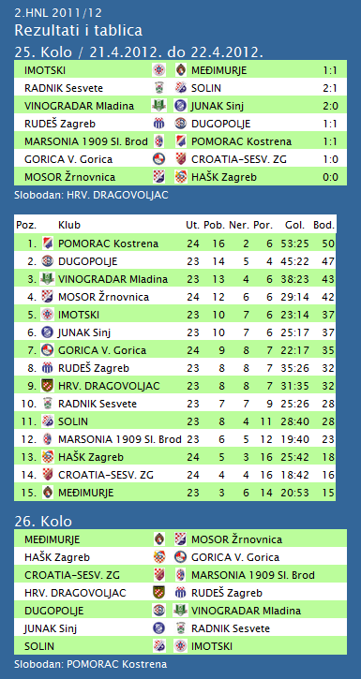

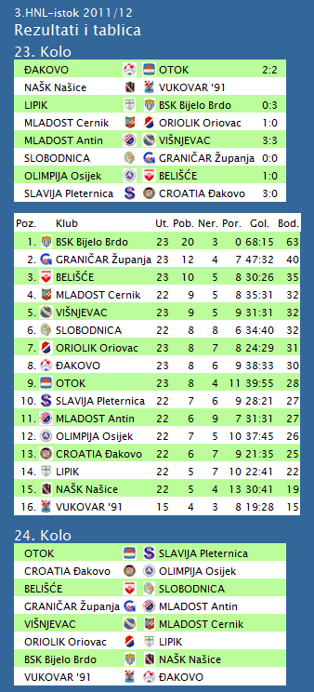

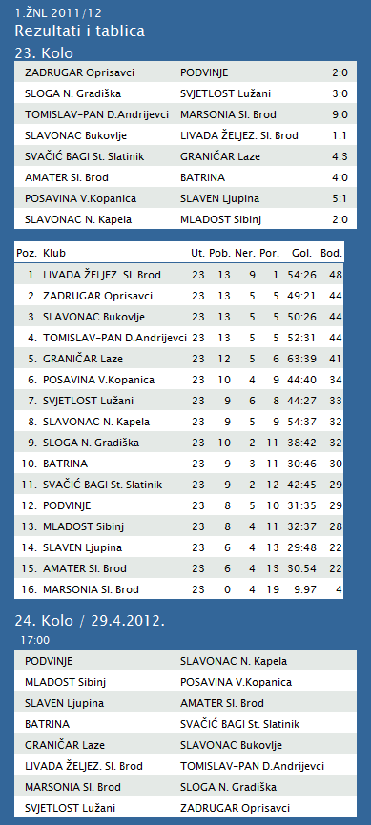

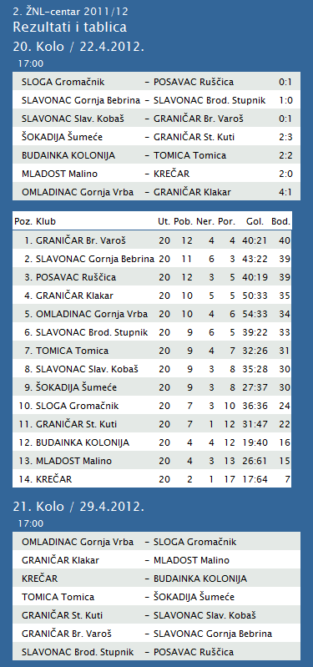

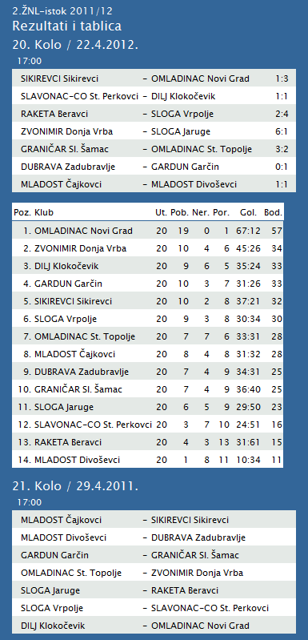

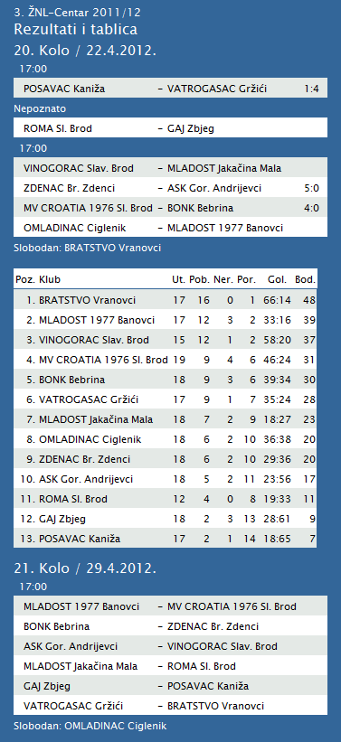

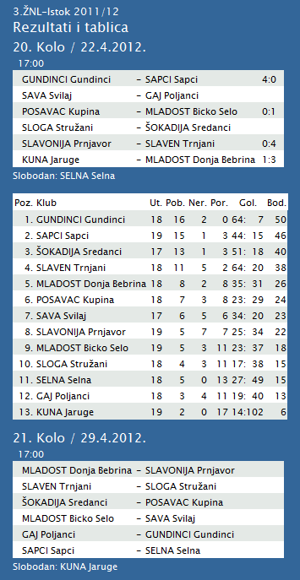

|  |  |  |  |  |  |  |  |  |  |  |
| --- | --- | --- | --- | --- | --- | --- | --- | --- | --- | --- |
| **TABLICA A1 MUŠKA LIGA ZA PRVAKA** | | | | | | | | | | |
| http://stats.stilu.net/templates/images/separator.gif | | | | | | | | | | |
| **#** | | **Klub** | **W** | **L** | **Bod** | **Omjer** | | | **Razlika** | |
| http://stats.stilu.net/templates/images/separator.gif | | | | | | | | | | |
| http://stats.stilu.net/templates/images/spacer.gif | **1** | [**KK Cibona** *(-1)*](javascript:;) | 10 | 0 | 20 | 878 | : | 709 | 169 | http://stats.stilu.net/templates/images/spacer.gif |
| http://stats.stilu.net/templates/images/separator.gif | | | | | | | | | | |
| http://stats.stilu.net/templates/images/spacer.gif | **2** | [**KK Cedevita**](javascript:;) | 8 | 3 | 19 | 952 | : | 820 | 132 | http://stats.stilu.net/templates/images/spacer.gif |
| http://stats.stilu.net/templates/images/separator.gif | | | | | | | | | | |
| http://stats.stilu.net/templates/images/spacer.gif | **3** | [**KK Zadar**](javascript:;) | 6 | 5 | 17 | 796 | : | 750 | 46 | http://stats.stilu.net/templates/images/spacer.gif |
| http://stats.stilu.net/templates/images/separator.gif | | | | | | | | | | |
| http://stats.stilu.net/templates/images/spacer.gif | **4** | [**KK Split** *(-2)*](javascript:;) | 6 | 3 | 15 | 747 | : | 735 | 12 | http://stats.stilu.net/templates/images/spacer.gif |
| http://stats.stilu.net/templates/images/separator.gif | | | | | | | | | | |
| http://stats.stilu.net/templates/images/spacer.gif | **5** | [**KK Zagreb** *(-2)*](javascript:;) | 5 | 4 | 14 | 814 | : | 736 | 78 | http://stats.stilu.net/templates/images/spacer.gif |
| http://stats.stilu.net/templates/images/separator.gif | | | | | | | | | | |
| http://stats.stilu.net/templates/images/spacer.gif | **6** | [**KK Jolly JBS** *(-1)*](javascript:;) | 2 | 8 | 12 | 750 | : | 876 | -126 | http://stats.stilu.net/templates/images/spacer.gif |
| http://stats.stilu.net/templates/images/separator.gif | | | | | | | | | | |
| http://stats.stilu.net/templates/images/spacer.gif | **7** | [**KK Brod Svjetlost** *(-1)*](javascript:;) | 2 | 8 | 12 | 643 | : | 815 | -172 | http://stats.stilu.net/templates/images/spacer.gif |
| http://stats.stilu.net/templates/images/separator.gif | | | | | | | | | | |
| http://stats.stilu.net/templates/images/spacer.gif | **8** | [**KK Zabok** *(-1)*](javascript:;) | 1 | 9 | 11 | 767 | : | 906 | -139 | http://stats.stilu.net/templates/images/spacer.gif |
| http://stats.stilu.net/templates/images/separator.gif | | | | | | | | | | |

**1. HRL muški**

|  |  |  |  |  |  |  |  |
| --- | --- | --- | --- | --- | --- | --- | --- |
| **Ukupni rezultati:** | | | | | | | |
|  |  | U | P | N | P | D |  | P | +/- | B |
|  |  |  |  |  |  |  |  |  |  |  |
| 1. | VIDOVEC-BIOS | 23 | 19 | 1 | 3 | 727 | : | 564 | 163 | 39 |
|  |  |  |  |  |  |  |  |  |  |  |
| 2. | MEDVEŠČAK NFD | 23 | 18 | 2 | 3 | 734 | : | 605 | 129 | 38 |
|  |  |  |  |  |  |  |  |  |  |  |
| 3. | MOSLAVINA | 23 | 15 | 2 | 6 | 668 | : | 594 | 74 | 32 |
|  |  |  |  |  |  |  |  |  |  |  |
| 4. | DUGO SELO | 23 | 13 | 2 | 8 | 738 | : | 725 | 13 | 28 |
|  |  |  |  |  |  |  |  |  |  |  |
| 5. | OSIJEK | 23 | 13 | 1 | 9 | 716 | : | 636 | 80 | 27 |
|  |  |  |  |  |  |  |  |  |  |  |
| 6. | SENJ-WALLENBORN | 23 | 12 | 2 | 9 | 649 | : | 655 | -6 | 26 |
|  |  |  |  |  |  |  |  |  |  |  |
| 7. | UMAG | 23 | 11 | 3 | 9 | 680 | : | 648 | 32 | 25 |
|  |  |  |  |  |  |  |  |  |  |  |
| 8. | ŽUPANJA | 23 | 9 | 2 | 12 | 602 | : | 620 | -18 | 20 |
|  |  |  |  |  |  |  |  |  |  |  |
| 9. | BIOGRAD | 23 | 9 | 2 | 12 | 663 | : | 705 | -42 | 20 |
|  |  |  |  |  |  |  |  |  |  |  |
| 10. | CRIKVENICA | 23 | 9 | 1 | 13 | 595 | : | 623 | -28 | 19 |
|  |  |  |  |  |  |  |  |  |  |  |
| 11. | ĐAKOVO | 23 | 8 | 1 | 14 | 656 | : | 708 | -52 | 17 |
|  |  |  |  |  |  |  |  |  |  |  |
| 12. | MLADI RUDAR | 22 | 6 | 2 | 14 | 552 | : | 612 | -60 | 13 |
|  |  |  |  |  |  |  |  |  |  |  |
| 13. | IVANČICA IVANEC | 22 | 5 | 1 | 16 | 598 | : | 672 | -74 | 11 |
|  |  |  |  |  |  |  |  |  |  |  |
| 14. | BROD | 23 | 2 | 0 | 21 | 593 | : | 804 | -211 | 4 |

**2. HRL sjever žene**

|  |  |  |  |  |  |  |  |
| --- | --- | --- | --- | --- | --- | --- | --- |
| **Ukupni rezultati:** | | | | | | | |
|  |  | U | P | N | P | D |  | P | +/- | B |
|  |  |  |  |  |  |  |  |  |  |  |
| 1. | OSIJEK PSC | 20 | 19 | 0 | 1 | 645 | : | 401 | 244 | 38 |
|  |  |  |  |  |  |  |  |  |  |  |
| 2. | BJELOVAR | 20 | 15 | 1 | 4 | 638 | : | 558 | 80 | 31 |
|  |  |  |  |  |  |  |  |  |  |  |
| 3. | BROD-GYMNASIUM | 20 | 13 | 2 | 5 | 564 | : | 477 | 87 | 28 |
|  |  |  |  |  |  |  |  |  |  |  |
| 4. | PODRAVKA-LINO | 20 | 13 | 2 | 5 | 615 | : | 556 | 59 | 28 |
|  |  |  |  |  |  |  |  |  |  |  |
| 5. | PITOMAČA | 20 | 11 | 2 | 7 | 626 | : | 588 | 38 | 24 |
|  |  |  |  |  |  |  |  |  |  |  |
| 6. | ZRINSKI | 20 | 10 | 1 | 9 | 551 | : | 558 | -7 | 21 |
|  |  |  |  |  |  |  |  |  |  |  |
| 7. | PETRIJEVCI | 20 | 9 | 1 | 10 | 633 | : | 649 | -16 | 19 |
|  |  |  |  |  |  |  |  |  |  |  |
| 8. | ĐURĐEVAC | 20 | 9 | 0 | 11 | 570 | : | 614 | -44 | 18 |
|  |  |  |  |  |  |  |  |  |  |  |
| 9. | DARDA | 20 | 8 | 0 | 12 | 572 | : | 580 | -8 | 16 |
|  |  |  |  |  |  |  |  |  |  |  |
| 10. | CERNA | 20 | 4 | 0 | 16 | 464 | : | 583 | -119 | 8 |
|  |  |  |  |  |  |  |  |  |  |  |
| 11. | IVANEC | 20 | 3 | 1 | 16 | 512 | : | 658 | -146 | 7 |
|  |  |  |  |  |  |  |  |  |  |  |
| 12. | VUKOVAR | 20 | 1 | 0 | 19 | 440 | : | 608 | -168 | 2 |