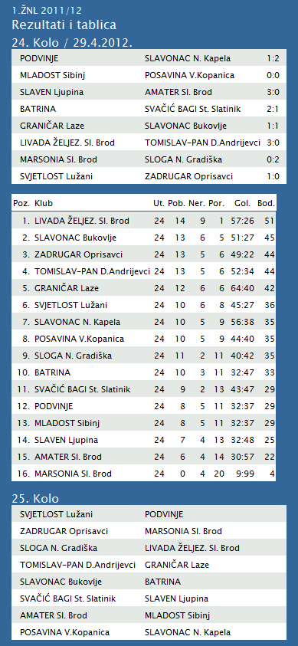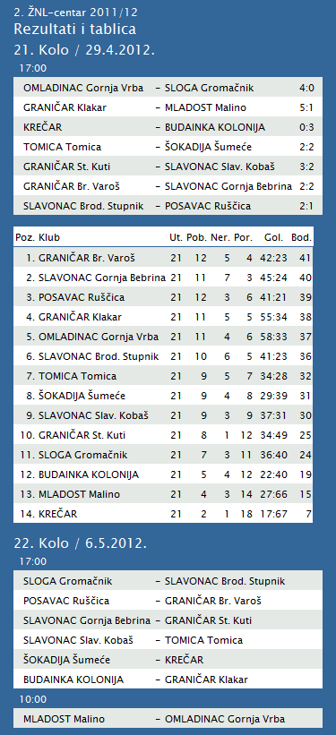

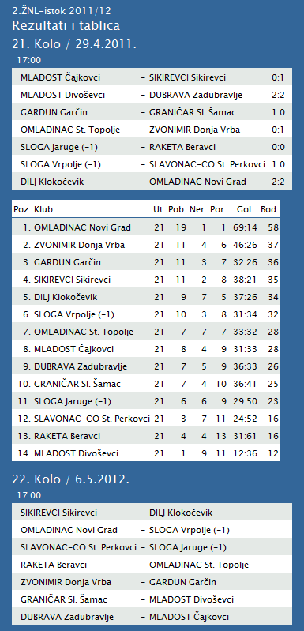

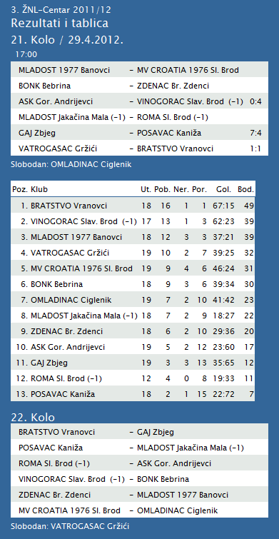

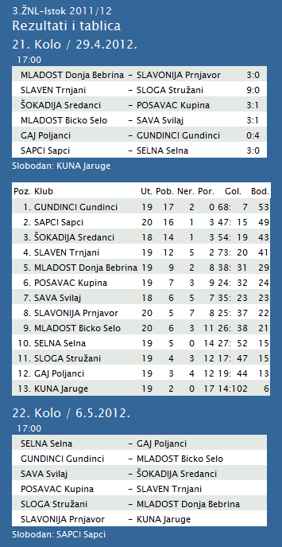

|  |  |  |  |  |  |  |  |  |  |  |
| --- | --- | --- | --- | --- | --- | --- | --- | --- | --- | --- |
| **TABLICA A1 MUŠKA LIGA ZA PRVAKA** | | | | | | | | | | |
| http://stats.stilu.net/templates/images/separator.gif | | | | | | | | | | |
| **#** | | **Klub** | **W** | **L** | **Bod** | **Omjer** | | | **Razlika** | |
| http://stats.stilu.net/templates/images/separator.gif | | | | | | | | | | |
| http://stats.stilu.net/templates/images/spacer.gif | **1** | [**KK Cibona**](javascript:;) | 12 | 0 | 24 | 1090 | : | 846 | 244 | http://stats.stilu.net/templates/images/spacer.gif |
| http://stats.stilu.net/templates/images/separator.gif | | | | | | | | | | |
| http://stats.stilu.net/templates/images/spacer.gif | **2** | [**KK Cedevita** *(-1)*](javascript:;) | 8 | 3 | 19 | 952 | : | 820 | 132 | http://stats.stilu.net/templates/images/spacer.gif |
| http://stats.stilu.net/templates/images/separator.gif | | | | | | | | | | |
| http://stats.stilu.net/templates/images/spacer.gif | **3** | [**KK Split** *(-1)*](javascript:;) | 8 | 3 | 19 | 912 | : | 882 | 30 | http://stats.stilu.net/templates/images/spacer.gif |
| http://stats.stilu.net/templates/images/separator.gif | | | | | | | | | | |
| http://stats.stilu.net/templates/images/spacer.gif | **4** | [**KK Zagreb**](javascript:;) | 6 | 6 | 18 | 1056 | : | 989 | 67 | http://stats.stilu.net/templates/images/spacer.gif |
| http://stats.stilu.net/templates/images/separator.gif | | | | | | | | | | |
| http://stats.stilu.net/templates/images/spacer.gif | **5** | [**KK Zadar** *(-1)*](javascript:;) | 6 | 5 | 17 | 796 | : | 750 | 46 | http://stats.stilu.net/templates/images/spacer.gif |
| http://stats.stilu.net/templates/images/separator.gif | | | | | | | | | | |
| http://stats.stilu.net/templates/images/spacer.gif | **6** | [**KK Jolly JBS** *(-1)*](javascript:;) | 2 | 9 | 13 | 827 | : | 959 | -132 | http://stats.stilu.net/templates/images/spacer.gif |
| http://stats.stilu.net/templates/images/separator.gif | | | | | | | | | | |
| http://stats.stilu.net/templates/images/spacer.gif | **7** | [**KK Brod Svjetlost** *(-1)*](javascript:;) | 2 | 9 | 13 | 714 | : | 902 | -188 | http://stats.stilu.net/templates/images/spacer.gif |
| http://stats.stilu.net/templates/images/separator.gif | | | | | | | | | | |
| http://stats.stilu.net/templates/images/spacer.gif | **8** | [**KK Zabok** *(-1)*](javascript:;) | 1 | 10 | 12 | 819 | : | 1018 | -199 | http://stats.stilu.net/templates/images/spacer.gif |
| http://stats.stilu.net/templates/images/separator.gif | | | | | | | | | | |

**1. HRL muški**

|  |  |  |  |  |  |  |  |
| --- | --- | --- | --- | --- | --- | --- | --- |
| **Ukupni rezultati:** | | | | | | | |
|  |  | U | P | N | P | D |  | P | +/- | B |
|  |  |  |  |  |  |  |  |  |  |  |
| 1. | VIDOVEC-BIOS | 24 | 20 | 1 | 3 | 764 | : | 598 | 166 | 41 |
|  |  |  |  |  |  |  |  |  |  |  |
| 2. | MEDVEŠČAK NFD | 24 | 19 | 2 | 3 | 763 | : | 633 | 130 | 40 |
|  |  |  |  |  |  |  |  |  |  |  |
| 3. | MOSLAVINA | 24 | 15 | 2 | 7 | 696 | : | 623 | 73 | 32 |
|  |  |  |  |  |  |  |  |  |  |  |
| 4. | DUGO SELO | 24 | 14 | 2 | 8 | 773 | : | 754 | 19 | 30 |
|  |  |  |  |  |  |  |  |  |  |  |
| 5. | SENJ-WALLENBORN | 24 | 13 | 2 | 9 | 683 | : | 682 | 1 | 28 |
|  |  |  |  |  |  |  |  |  |  |  |
| 6. | OSIJEK | 24 | 13 | 1 | 10 | 750 | : | 673 | 77 | 27 |
|  |  |  |  |  |  |  |  |  |  |  |
| 7. | UMAG | 24 | 12 | 3 | 9 | 712 | : | 670 | 42 | 27 |
|  |  |  |  |  |  |  |  |  |  |  |
| 8. | ŽUPANJA | 24 | 10 | 2 | 12 | 636 | : | 645 | -9 | 22 |
|  |  |  |  |  |  |  |  |  |  |  |
| 9. | CRIKVENICA | 24 | 9 | 2 | 13 | 622 | : | 650 | -28 | 20 |
|  |  |  |  |  |  |  |  |  |  |  |
| 10. | BIOGRAD | 24 | 9 | 2 | 13 | 685 | : | 737 | -52 | 20 |
|  |  |  |  |  |  |  |  |  |  |  |
| 11. | ĐAKOVO | 24 | 8 | 1 | 15 | 685 | : | 743 | -58 | 17 |
|  |  |  |  |  |  |  |  |  |  |  |
| 12. | IVANČICA IVANEC | 24 | 6 | 2 | 16 | 649 | : | 719 | -70 | 14 |
|  |  |  |  |  |  |  |  |  |  |  |
| 13. | MLADI RUDAR | 24 | 6 | 2 | 16 | 599 | : | 670 | -71 | 13 |
|  |  |  |  |  |  |  |  |  |  |  |
| 14. | BROD | 24 | 2 | 0 | 22 | 618 | : | 838 | -220 | 4 |
|  |  |  |  |  |  |  |  |  |  |  |

**2. HRL sjever žene**

|  |  |  |  |  |  |  |  |
| --- | --- | --- | --- | --- | --- | --- | --- |
| **Ukupni rezultati:** | | | | | | | |
|  |  | U | P | N | P | D |  | P | +/- | B |
|  |  |  |  |  |  |  |  |  |  |  |
| 1. | OSIJEK PSC | 21 | 20 | 0 | 1 | 678 | : | 424 | 254 | 40 |
|  |  |  |  |  |  |  |  |  |  |  |
| 2. | BJELOVAR | 21 | 15 | 1 | 5 | 661 | : | 591 | 70 | 31 |
|  |  |  |  |  |  |  |  |  |  |  |
| 3. | PODRAVKA-LINO | 21 | 14 | 2 | 5 | 665 | : | 585 | 80 | 30 |
|  |  |  |  |  |  |  |  |  |  |  |
| 4. | BROD-GYMNASIUM | 21 | 13 | 3 | 5 | 590 | : | 503 | 87 | 29 |
|  |  |  |  |  |  |  |  |  |  |  |
| 5. | PITOMAČA | 21 | 12 | 2 | 7 | 673 | : | 608 | 65 | 26 |
|  |  |  |  |  |  |  |  |  |  |  |
| 6. | ZRINSKI | 21 | 11 | 1 | 9 | 580 | : | 575 | 5 | 23 |
|  |  |  |  |  |  |  |  |  |  |  |
| 7. | PETRIJEVCI | 21 | 9 | 1 | 11 | 654 | : | 673 | -19 | 19 |
|  |  |  |  |  |  |  |  |  |  |  |
| 8. | ĐURĐEVAC | 21 | 9 | 0 | 12 | 590 | : | 661 | -71 | 18 |
|  |  |  |  |  |  |  |  |  |  |  |
| 9. | DARDA | 21 | 8 | 1 | 12 | 598 | : | 606 | -8 | 17 |
|  |  |  |  |  |  |  |  |  |  |  |
| 10. | IVANEC | 21 | 4 | 1 | 16 | 536 | : | 679 | -143 | 9 |
|  |  |  |  |  |  |  |  |  |  |  |
| 11. | CERNA | 21 | 4 | 0 | 17 | 481 | : | 612 | -131 | 8 |
|  |  |  |  |  |  |  |  |  |  |  |
| 12. | VUKOVAR | 21 | 1 | 0 | 20 | 469 | : | 658 | -189 | 2 |