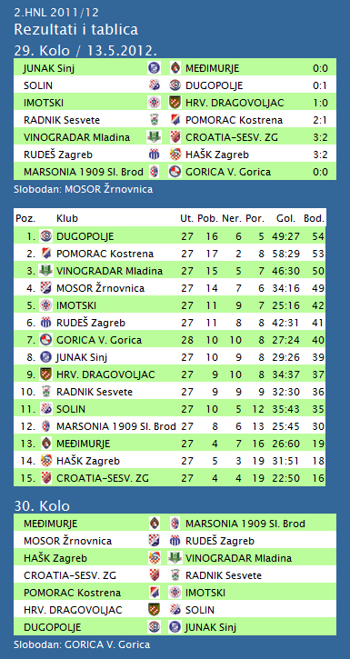

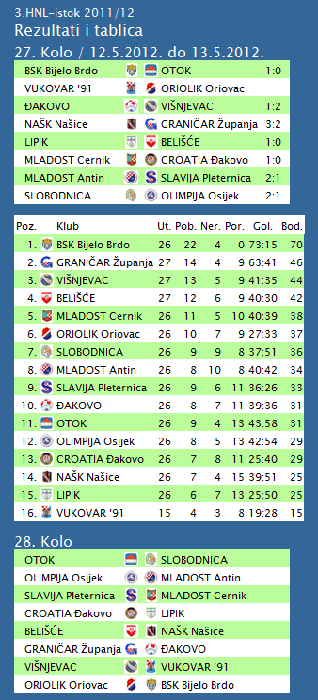

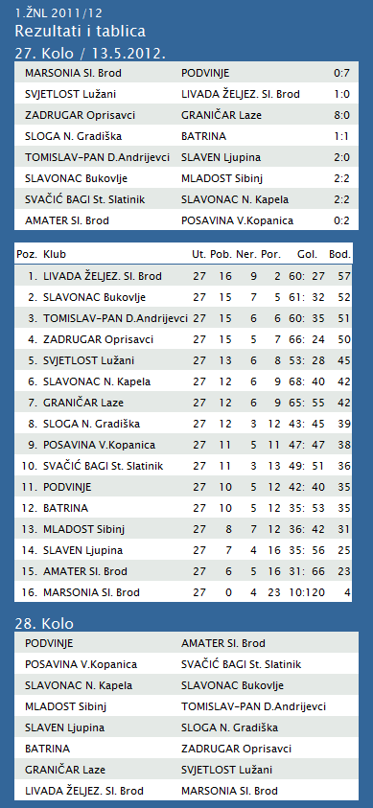

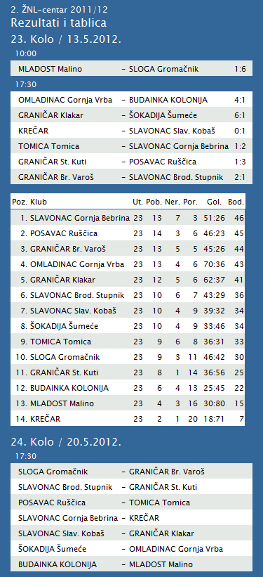

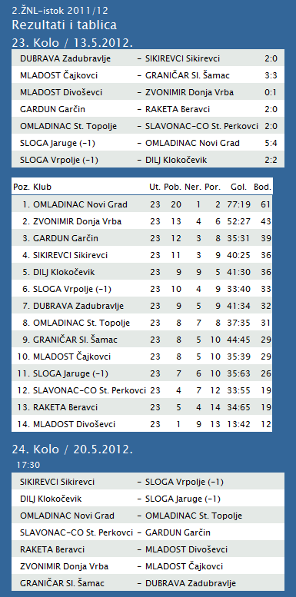

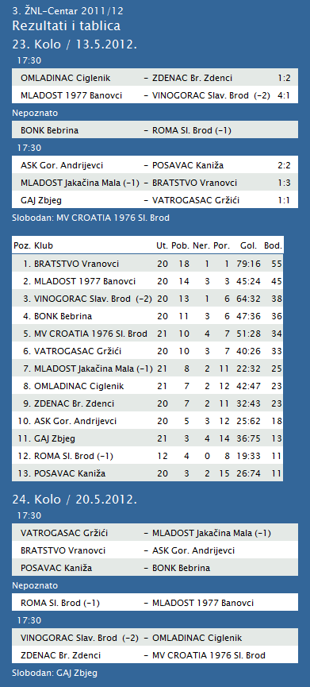

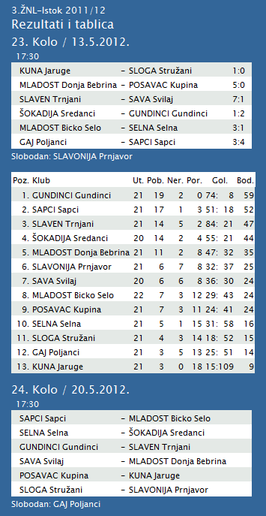

|  |  |  |  |  |  |  |  |  |  |  |
| --- | --- | --- | --- | --- | --- | --- | --- | --- | --- | --- |
| **TABLICA A1 MUŠKA LIGA ZA PRVAKA** | | | | | | | | | | |
| http://stats.stilu.net/templates/images/separator.gif | | | | | | | | | | |
| **#** | | **Klub** | **W** | **L** | **Bod** | **Omjer** | | | **Razlika** | |
| http://stats.stilu.net/templates/images/separator.gif | | | | | | | | | | |
| http://stats.stilu.net/templates/images/spacer.gif | **1** | [**KK Cibona**](javascript:;) | 14 | 0 | 28 | 1263 | : | 996 | 267 | http://stats.stilu.net/templates/images/spacer.gif |
| http://stats.stilu.net/templates/images/separator.gif | | | | | | | | | | |
| http://stats.stilu.net/templates/images/spacer.gif | **2** | [**KK Cedevita**](javascript:;) | 11 | 3 | 25 | 1218 | : | 1022 | 196 | http://stats.stilu.net/templates/images/spacer.gif |
| http://stats.stilu.net/templates/images/separator.gif | | | | | | | | | | |
| http://stats.stilu.net/templates/images/spacer.gif | **3** | [**KK Split**](javascript:;) | 10 | 4 | 24 | 1149 | : | 1120 | 29 | http://stats.stilu.net/templates/images/spacer.gif |
| http://stats.stilu.net/templates/images/separator.gif | | | | | | | | | | |
| http://stats.stilu.net/templates/images/spacer.gif | **4** | [**KK Zadar**](javascript:;) | 8 | 6 | 22 | 1031 | : | 985 | 46 | http://stats.stilu.net/templates/images/spacer.gif |
| http://stats.stilu.net/templates/images/separator.gif | | | | | | | | | | |
| http://stats.stilu.net/templates/images/spacer.gif | **5** | [**KK Zagreb**](javascript:;) | 6 | 8 | 20 | 1212 | : | 1156 | 56 | http://stats.stilu.net/templates/images/spacer.gif |
| http://stats.stilu.net/templates/images/separator.gif | | | | | | | | | | |
| http://stats.stilu.net/templates/images/spacer.gif | **6** | [**KK Brod Svjetlost**](javascript:;) | 3 | 11 | 17 | 964 | : | 1149 | -185 | http://stats.stilu.net/templates/images/spacer.gif |
| http://stats.stilu.net/templates/images/separator.gif | | | | | | | | | | |
| http://stats.stilu.net/templates/images/spacer.gif | **7** | [**KK Jolly JBS**](javascript:;) | 2 | 12 | 16 | 1022 | : | 1209 | -187 | http://stats.stilu.net/templates/images/spacer.gif |
| http://stats.stilu.net/templates/images/separator.gif | | | | | | | | | | |
| http://stats.stilu.net/templates/images/spacer.gif | **8** | [**KK Zabok**](javascript:;) | 2 | 12 | 16 | 1056 | : | 1278 | -222 | http://stats.stilu.net/templates/images/spacer.gif |
| http://stats.stilu.net/templates/images/separator.gif | | | | | | | | | | |

**1. HRL muški**

|  |  |  |  |  |  |  |  |
| --- | --- | --- | --- | --- | --- | --- | --- |
| **Ukupni rezultati:** | | | | | | | |
|  |  | U | P | N | P | D |  | P | +/- | B |
|  |  |  |  |  |  |  |  |  |  |  |
| 1. | VIDOVEC-BIOS | 26 | 22 | 1 | 3 | 848 | : | 649 | 199 | 45 |
|  |  |  |  |  |  |  |  |  |  |  |
| 2. | MEDVEŠČAK NFD | 25 | 20 | 2 | 3 | 799 | : | 665 | 134 | 42 |
|  |  |  |  |  |  |  |  |  |  |  |
| 3. | MOSLAVINA | 25 | 16 | 2 | 7 | 726 | : | 650 | 76 | 34 |
|  |  |  |  |  |  |  |  |  |  |  |
| 4. | DUGO SELO | 26 | 14 | 2 | 10 | 832 | : | 835 | -3 | 30 |
|  |  |  |  |  |  |  |  |  |  |  |
| 5. | OSIJEK | 25 | 14 | 1 | 10 | 787 | : | 702 | 85 | 29 |
|  |  |  |  |  |  |  |  |  |  |  |
| 6. | SENJ-WALLENBORN | 25 | 13 | 2 | 10 | 708 | : | 711 | -3 | 28 |
|  |  |  |  |  |  |  |  |  |  |  |
| 7. | UMAG | 25 | 12 | 3 | 10 | 744 | : | 706 | 38 | 27 |
|  |  |  |  |  |  |  |  |  |  |  |
| 8. | ŽUPANJA | 25 | 11 | 2 | 12 | 661 | : | 664 | -3 | 24 |
|  |  |  |  |  |  |  |  |  |  |  |
| 9. | CRIKVENICA | 25 | 10 | 2 | 13 | 651 | : | 675 | -24 | 22 |
|  |  |  |  |  |  |  |  |  |  |  |
| 10. | BIOGRAD | 25 | 10 | 2 | 13 | 724 | : | 771 | -47 | 22 |
|  |  |  |  |  |  |  |  |  |  |  |
| 11. | ĐAKOVO | 25 | 8 | 1 | 16 | 712 | : | 773 | -61 | 17 |
|  |  |  |  |  |  |  |  |  |  |  |
| 12. | IVANČICA IVANEC | 25 | 6 | 2 | 17 | 668 | : | 744 | -76 | 14 |
|  |  |  |  |  |  |  |  |  |  |  |
| 13. | MLADI RUDAR | 25 | 6 | 2 | 17 | 620 | : | 710 | -90 | 13 |
|  |  |  |  |  |  |  |  |  |  |  |
| 14. | BROD | 25 | 2 | 0 | 23 | 652 | : | 877 | -225 | 4 |
|  |  |  |  |  |  |  |  |  |  |  |

**2. HRL sjever žene**

|  |  |  |  |  |  |  |  |
| --- | --- | --- | --- | --- | --- | --- | --- |
| **Ukupni rezultati:** | | | | | | | |
|  |  | U | P | N | P | D |  | P | +/- | B |
|  |  |  |  |  |  |  |  |  |  |  |
| 1. | OSIJEK PSC | 22 | 21 | 0 | 1 | 707 | : | 446 | 261 | 42 |
|  |  |  |  |  |  |  |  |  |  |  |
| 2. | PODRAVKA-LINO | 22 | 15 | 2 | 5 | 693 | : | 610 | 83 | 32 |
|  |  |  |  |  |  |  |  |  |  |  |
| 3. | BROD-GYMNASIUM | 22 | 14 | 3 | 5 | 627 | : | 526 | 101 | 31 |
|  |  |  |  |  |  |  |  |  |  |  |
| 4. | BJELOVAR | 22 | 15 | 1 | 6 | 686 | : | 619 | 67 | 31 |
|  |  |  |  |  |  |  |  |  |  |  |
| 5. | PITOMAČA | 22 | 12 | 2 | 8 | 696 | : | 645 | 51 | 26 |
|  |  |  |  |  |  |  |  |  |  |  |
| 6. | ZRINSKI | 22 | 11 | 2 | 9 | 610 | : | 605 | 5 | 24 |
|  |  |  |  |  |  |  |  |  |  |  |
| 7. | PETRIJEVCI | 22 | 9 | 2 | 11 | 684 | : | 703 | -19 | 20 |
|  |  |  |  |  |  |  |  |  |  |  |
| 8. | ĐURĐEVAC | 22 | 9 | 0 | 13 | 612 | : | 690 | -78 | 18 |
|  |  |  |  |  |  |  |  |  |  |  |
| 9. | DARDA | 22 | 8 | 1 | 13 | 622 | : | 637 | -15 | 17 |
|  |  |  |  |  |  |  |  |  |  |  |
| 10. | IVANEC | 22 | 5 | 1 | 16 | 568 | : | 702 | -134 | 11 |
|  |  |  |  |  |  |  |  |  |  |  |
| 11. | CERNA | 22 | 5 | 0 | 17 | 512 | : | 636 | -124 | 10 |
|  |  |  |  |  |  |  |  |  |  |  |
| 12. | VUKOVAR | 22 | 1 | 0 | 21 | 492 | : | 690 | -198 | 2 |