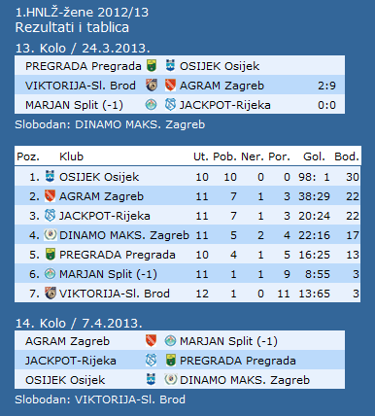

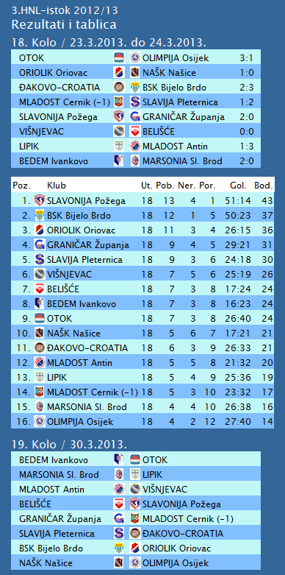

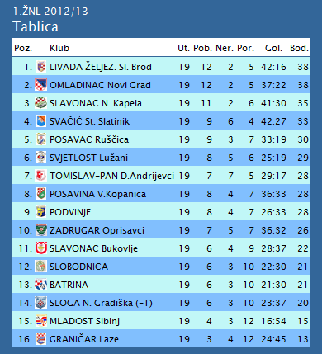

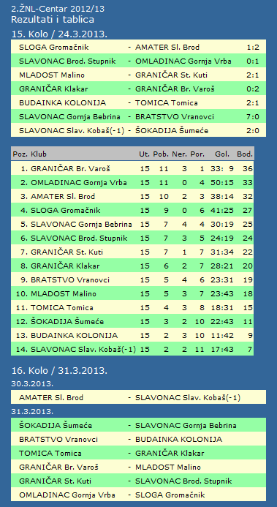

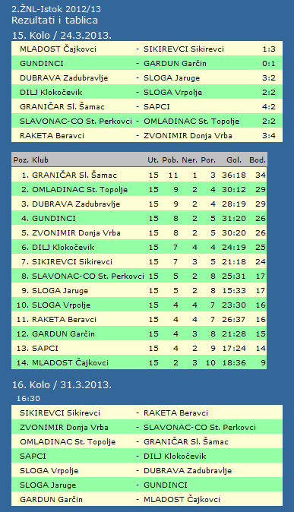

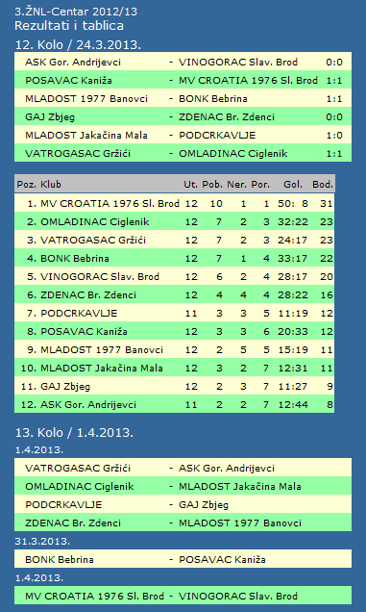

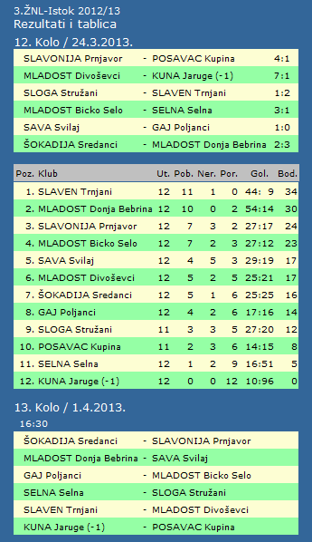

|  |  |  |  |  |  |  |  |  |  |  |
| --- | --- | --- | --- | --- | --- | --- | --- | --- | --- | --- |
| **TABLICA A1 MUŠKA LIGA ZA OSTANAK** | | | | | | | | | | |
| http://stats.stilu.net/templates/images/separator.gif | | | | | | | | | | |
| **#** | | **Klub** | **W** | **L** | **Bod** | **Omjer** | | | **Razlika** | |
| http://stats.stilu.net/templates/images/separator.gif | | | | | | | | | | |
| http://stats.stilu.net/templates/images/spacer.gif | **1** | [**KK Đuro Đaković**](javascript:;) | 9 | 2 | 20 | 840 | : | 778 | 62 | http://stats.stilu.net/templates/images/spacer.gif |
| http://stats.stilu.net/templates/images/separator.gif | | | | | | | | | | |
| http://stats.stilu.net/templates/images/spacer.gif | **2** | [**KK Vrijednosnice OS Darda**](javascript:;) | 8 | 2 | 18 | 782 | : | 686 | 96 | http://stats.stilu.net/templates/images/spacer.gif |
| http://stats.stilu.net/templates/images/separator.gif | | | | | | | | | | |
| http://stats.stilu.net/templates/images/spacer.gif | **3** | [**KK Osječki sokol**](javascript:;) | 5 | 5 | 15 | 751 | : | 771 | -20 | http://stats.stilu.net/templates/images/spacer.gif |
| http://stats.stilu.net/templates/images/separator.gif | | | | | | | | | | |
| http://stats.stilu.net/templates/images/spacer.gif | **4** | [**KK Križevci**](javascript:;) | 4 | 7 | 15 | 774 | : | 828 | -54 | http://stats.stilu.net/templates/images/spacer.gif |
| http://stats.stilu.net/templates/images/separator.gif | | | | | | | | | | |
| http://stats.stilu.net/templates/images/spacer.gif | **5** | [**KK Zabok**](javascript:;) | 4 | 6 | 14 | 781 | : | 739 | 42 | http://stats.stilu.net/templates/images/spacer.gif |
| http://stats.stilu.net/templates/images/separator.gif | | | | | | | | | | |
| http://stats.stilu.net/templates/images/spacer.gif | **6** | [**KK Dubrovnik**](javascript:;) | 1 | 9 | 11 | 693 | : | 819 | -126 | http://stats.stilu.net/templates/images/spacer.gif |
| http://stats.stilu.net/templates/images/separator.gif | | | | | | | | | | |

**2. HRL sjever muški**

|  |  |  |  |  |  |  |  |
| --- | --- | --- | --- | --- | --- | --- | --- |
| **Tablica lige** | | | | | | | |
|  |  | U | P | N | P | D |  | P | +/- | B |
|  |  |  |  |  |  |  |  |  |  |  |
| 1. | PRELOG | 16 | 13 | 2 | 1 | 560 | : | 451 | 109 | 28 |
|  |  |  |  |  |  |  |  |  |  |  |
| 2. | IVANČICA IVANEC | 15 | 11 | 1 | 3 | 445 | : | 377 | 68 | 23 |
|  |  |  |  |  |  |  |  |  |  |  |
| 3. | IVANSKA | 16 | 10 | 1 | 5 | 458 | : | 455 | 3 | 21 |
|  |  |  |  |  |  |  |  |  |  |  |
| 4. | BOROVO | 15 | 7 | 0 | 8 | 459 | : | 437 | 22 | 14 |
|  |  |  |  |  |  |  |  |  |  |  |
| 5. | BELI MANASTIR | 15 | 6 | 1 | 8 | 431 | : | 447 | -16 | 13 |
|  |  |  |  |  |  |  |  |  |  |  |
| 6. | BROD | 15 | 6 | 2 | 7 | 405 | : | 477 | -72 | 13 |
|  |  |  |  |  |  |  |  |  |  |  |
| 7. | POŽEGA | 15 | 5 | 2 | 8 | 393 | : | 383 | 10 | 12 |
|  |  |  |  |  |  |  |  |  |  |  |
| 8. | SLATINA | 16 | 6 | 0 | 10 | 435 | : | 443 | -8 | 12 |
|  |  |  |  |  |  |  |  |  |  |  |
| 9. | VIRO-VIROVITICA | 16 | 6 | 0 | 10 | 436 | : | 457 | -21 | 11 |
|  |  |  |  |  |  |  |  |  |  |  |
| 10. | GAREŠNICA | 16 | 5 | 1 | 10 | 473 | : | 498 | -25 | 11 |
|  |  |  |  |  |  |  |  |  |  |  |
| 11. | ILOVA | 15 | 5 | 0 | 10 | 396 | : | 466 | -70 | 9 |
|  |  |  |  |  |  |  |  |  |  |  |

**2. HRL sjever žene**

|  |  |  |  |  |  |  |  |
| --- | --- | --- | --- | --- | --- | --- | --- |
| **Tablica lige** | | | | | | | |
|  |  | U | P | N | P | D |  | P | +/- | B |
|  |  |  |  |  |  |  |  |  |  |  |
| 1. | ZRINSKI | 13 | 11 | 2 | 0 | 384 | : | 295 | 89 | 23 |
|  |  |  |  |  |  |  |  |  |  |  |
| 2. | PODRAVKA-LINO | 13 | 11 | 0 | 2 | 404 | : | 296 | 108 | 22 |
|  |  |  |  |  |  |  |  |  |  |  |
| 3. | PITOMAČA | 14 | 10 | 1 | 3 | 457 | : | 369 | 88 | 21 |
|  |  |  |  |  |  |  |  |  |  |  |
| 4. | PAN-ĐAKOVO | 14 | 8 | 0 | 6 | 333 | : | 333 | 0 | 16 |
|  |  |  |  |  |  |  |  |  |  |  |
| 5. | BJELOVAR | 13 | 8 | 0 | 5 | 382 | : | 343 | 39 | 15 |
|  |  |  |  |  |  |  |  |  |  |  |
| 6. | TVIN-TRGOCENTAR | 13 | 7 | 1 | 5 | 372 | : | 344 | 28 | 15 |
|  |  |  |  |  |  |  |  |  |  |  |
| 7. | BROD-GYMNASIUM | 14 | 4 | 0 | 10 | 327 | : | 406 | -79 | 7 |
|  |  |  |  |  |  |  |  |  |  |  |
| 8. | IVANEC | 14 | 3 | 0 | 11 | 359 | : | 460 | -101 | 6 |
|  |  |  |  |  |  |  |  |  |  |  |
| 9. | DARDA | 14 | 3 | 0 | 11 | 338 | : | 393 | -55 | 5 |
|  |  |  |  |  |  |  |  |  |  |  |
| 10. | ĐURĐEVAC | 14 | 1 | 0 | 13 | 332 | : | 449 | -117 | 2 |